 | The National Disability Insurance Scheme (or NDIS) is the new way for people with disability to get the help and support they need to live an ordinary life.
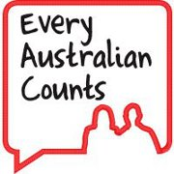 | Every Australian Counts is a campaign. A campaign is a group of people who come together to fight for something they want.  Every Australian Counts was started to fight for the NDIS and to make it happen.  Now the NDIS is here. But we want to keep fighting to make sure it is even better.
 | We want to ask you some questions about how to make the NDIS better. What do you think needs to change?
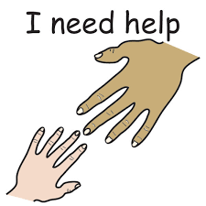 | But first let us tell you a little bit about the NDIS.  The NDIS began to make sure people with disability get the help they need. This might be the same things as everyone else:  - getting a job  - going out with friends  - joining a group.
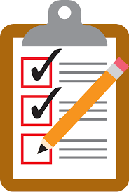 | Everyone who gets help from the NDIS is called an NDIS participant. Every NDIS participant has a plan.  The plan says what your goals are, and what help you need to reach those goals.  The goals might be things like:  - getting a job, or  - moving out of home.
The plan then says what money and support you will get to do those things.

Once you have a plan, you can go and get the help you need.

That’s a very short summary about the NDIS – you might like to learn more.

If you want to know more you can look on the NDIS website:

https://www.ndis.gov.au/participants/whatisndis.html

https://www.ndis.gov.au/news/easy-read-word-list.html

https://www.ndis.gov.au/participants/reviewingmyplan.html

So now our questions.

We are just going to ask questions about the NDIS plans. You might have some other ideas about how to make the NDIS better – we want to hear those too. We will come back and ask about those another time.

NDIS Plans

Lots of people have said things about the NDIS like this:

- The NDIS is confusing and hard to understand.
- There are lots of new words and terms to learn.
- It’s hard to know what to do to get ready for the NDIS.
- The people who work at the NDIS don’t always know enough about people with disability.

Questions for you to answer

Do you think the NDIS should give people clear and simple information about the NDIS so they know what to expect?

Yes or No? (you can circle your answer)

Do you think the NDIS should give people one person to speak to so they can help them and answer their questions?

Yes or No (you can circle your answer)

Do you think the NDIS should let people look at their plan before it is finished?

Yes or No (you can circle your answer)

Do you think the NDIS should let people make small changes to their plan after it is finished?

Yes or No (you can circle your answer)

Do you think people who work at the NDIS should have lots of training and experience with people with different kinds of disabilities?

Yes or No (you can circle your answer)

Do you have any other ideas about how to make things better with NDIS plans?
You can write them below.

Thank you for your help.

We are asking lots of people these questions. When we have finished, we will collect all the answers and give them to the people who work at the NDIS.

Hopefully it will give them some ideas on how to make things better for people.

