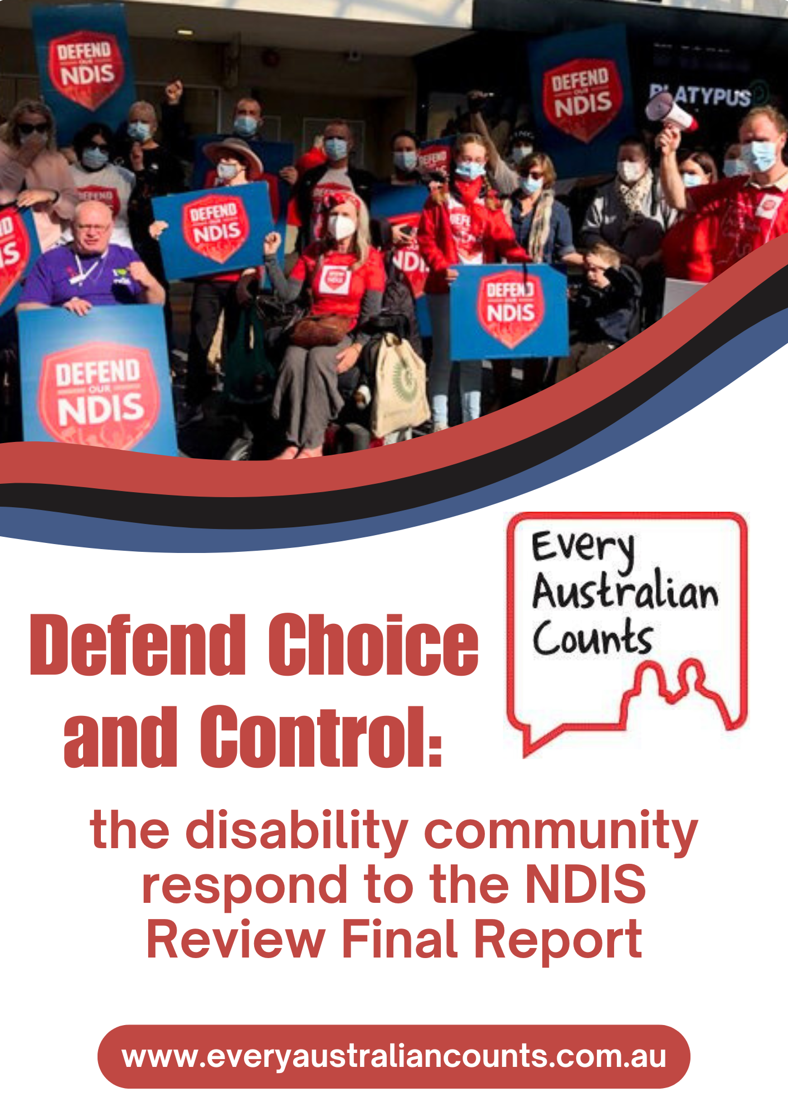

Defend Choice and Control:
the disability community respond to
the NDIS Review Final Report

Contents

Contents 2
Acknowledgements 3
About Every Australian Counts 3
Statement from Independent Chair of Every Australian Counts 4
Executive Summary 5
Recommendation 17: Mandatory Provider Registration and Enrolment 7
Serious consequences feared by participants in regional and rural areas 9
Mandatory registration to increase cost pressures 9
NDIS registered providers were more likely to support mandatory registration 10
Mandatory registration for some but not all 10
Recommendation 9: Housing and Living Supports 12
Recommendation 4: Navigators 16
Benefits to the recommendation and possible alternate models 22
Recommendation 3: Eligibility and Access 24
Recommendation 6: Early Intervention 31
Supportive opinions for the recommended changes to early intervention 32
Negative commentary about the recommended changes to early intervention 33
Recommendation 3: Changes to Planning 37
Recommendation 7: Psychosocial Disability 43
Positive commentary for the recommended changes to psychosocial disability supports. 44
Negative opinions about the recommended changes to psychosocial disability supports 45
Recommendation 1: Foundational Supports 48
Contact Details 55
Appendix 1: Tables of Survey Results By Respondent Type 56

Acknowledgements

Every Australian Counts acknowledge the traditional owners of the lands on which this submission was produced. We acknowledge the deep spiritual connection to these lands which was never ceded, and extend our respects to community members and Elders past and present.

Our thanks to all the people with disability, family members, nominees, advocates and providers who responded to our survey on the independent NDIS Review recommendations. Thanks to Professor Jennifer Smith-Merry and Dr Damian Mellifont from the Centre for Disability Research and Policy at the University of Sydney who provided an initial analysis that informed the independent analysis done by Every Australian Counts.

About Every Australian Counts

Every Australian Counts (EAC) is the grassroots campaign that fought for the introduction of the National Disability Insurance Scheme (NDIS) and won. EAC is made up of hundreds of thousands of people with disability, families, carers, and those who work to support them who have come together to fight for a fair go for people with disability in Australia.

The campaign was officially launched in 2011. Just two years later in July 2013 the National Disability Insurance Scheme started in a small number of locations. It has now been rolled out across Australia. At the time of writing this report, there are 646,449 people with disability being supported by the NDIS to live the life they choose.

Every Australian Counts didn’t end with the introduction of the NDIS. The campaign continues to fight to make sure the NDIS delivers on its promise to people with disability with disability in Australia.

Statement from Independent Chair of Every Australian Counts,

Dr George Taleporos

This survey is critically important because it gives voice to our community about how recommendations by the NDIS Review could affect our lives. Our community is greatly concerned that some of the changes proposed by the NDIS Review attack the key foundations of the NDIS that we fought for. Our community have spoken and have said a strong NO to any changes that will impact on our ability to be in control of where we live, who we live with and who provides our support.

As government prepares its response to the NDIS Review, we ask them to listen to the voices of the disability community and our clear message to defend participant choice and control in the NDIS. We want to work collaboratively with the government to ensure that the NDIS stays true to its original intentions and ask the Minister to meet with us to discuss our concerns and how they will be addressed.

Executive Summary

Every Australian Counts undertook a survey to understand the views of our community regarding the recommendations of the NDIS Review. 1373 people took part in the survey, with 853 completed surveys received. 71% were NDIS participants and family members, 15% were service providers and the remainder were advocates or others.

The greatest concerns were related to the recommendation to require participants to be restricted to registered or enrolled providers. 68% of NDIS participants surveyed disagreed or strongly disagreed with the NDIS Review’s proposal for mandatory provider registration, while only 13% supported the proposal. Family members and nominees surveyed also opposed the changes. 58% of family members and nominees surveyed disagreed or strongly disagreed with the NDIS review proposal while only 22% of this group were in favour.

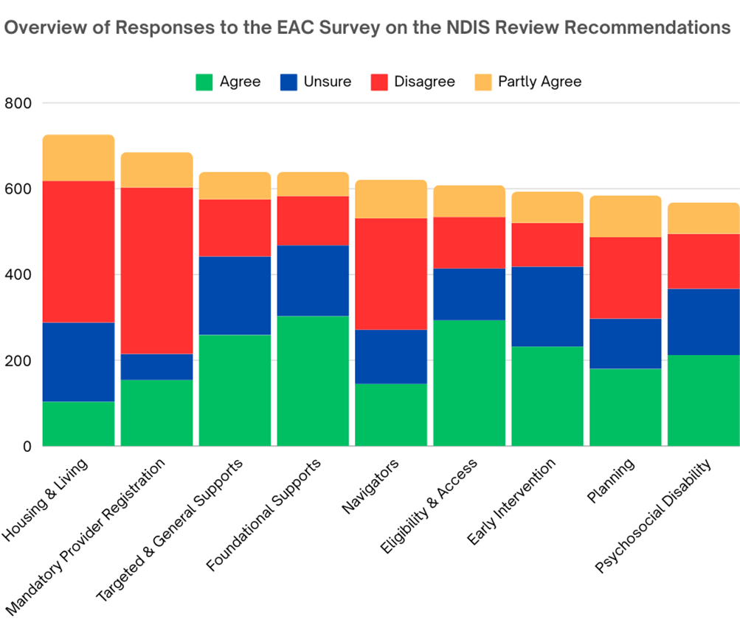
* See note at bottom of Executive Summary

NDIS providers were more supportive of the changes. 44% of providers agreed or strongly agreed with the proposed changes.

NDIS participants and family members expressed deep concerns with the proposed registration framework as outlined in the NDIS review, specifically:
- A loss of choice and control over their support.
- Registration and the NDIS Commission being ineffective in keeping individuals safe from abuse
- Increasing costs of support.
- Loss of access to support especially in regional and remote Australia, where there are minimal or no registered providers.

There was also a strong opposition towards the housing and living recommendations, with only 14% of survey respondents supporting all of these recommendations. Specifically, respondents were strongly opposed to the recommended model proposing one support worker for every three participants (1:3 ratio). They argued that the changes contravene the core principles of choice, control and individualised support, elements that have been fundamental to the NDIS's success.

Concerns related to choice and control were a strong theme throughout the report with participants expressing deep concern that a shift to block funded Navigators and foundational supports would impact on individual choice. 42% of survey respondents disagreed or strongly disagreed with the recommendation for navigators, with a further 14% agreeing with some of the changes but not others. People with disability and families highly valued their ability to choose their Support Coordinators, who have been instrumental in supporting many people to navigate complex disability and mainstream support services; and did not support any changes that would take this away.

* Please note that in the graphs included in this report, the key is worded a little differently to the response options in the survey, in order to fit on the chart.

Language used in graphs in this report | Language used in the survey and the tables in Appendix 1 of this report
Agree | Agree  Strongly Agree
Unsure | Unsure
Disagree | Disagree  Strongly Disagree
Partly Agree | I agree with some of the changes but not others

Recommendation 17: Mandatory Provider Registration and Enrolment

The NDIS Review Report recommends a new model of mandatory registration, or enrolment, for all providers. There would be 4 levels of provider registration available. There would no longer be Plan Management. Participants would use an NDIS card to pay for supports. Participants would only be able to use NDIS registered or enrolled providers. (see page 212 of the report)

The 4 levels of registration or enrolment for providers would be:
- Advanced Registration - for high-risk supports like daily living supports in group homes.
- General Registration - for medium-risk supports like high intensity daily personal activities, complex bowel care or injections, and supports with significant 1:1 contact with people with disability.
- Basic Registration - for lower-risk supports like sole traders, smaller organisations, social and community participation supports, and supports with more limited 1:1 contact with people with disability.
- Enrolment - for lowest-risk supports like consumables, equipment, technology, home and vehicle modifications, gardeners and cleaners.

See page 214 of the report to understand what providers would be expected to do to register or enrol for the different levels.

68% of NDIS participants surveyed disagreed or strongly disagreed with the NDIS Review proposal for mandatory provider registration, while only 13% supported the proposal. Family members and nominees surveyed also opposed the changes. 58% of family members and nominees surveyed disagreed or strongly disagreed with the NDIS review proposal while only 22% of this group were in favour.

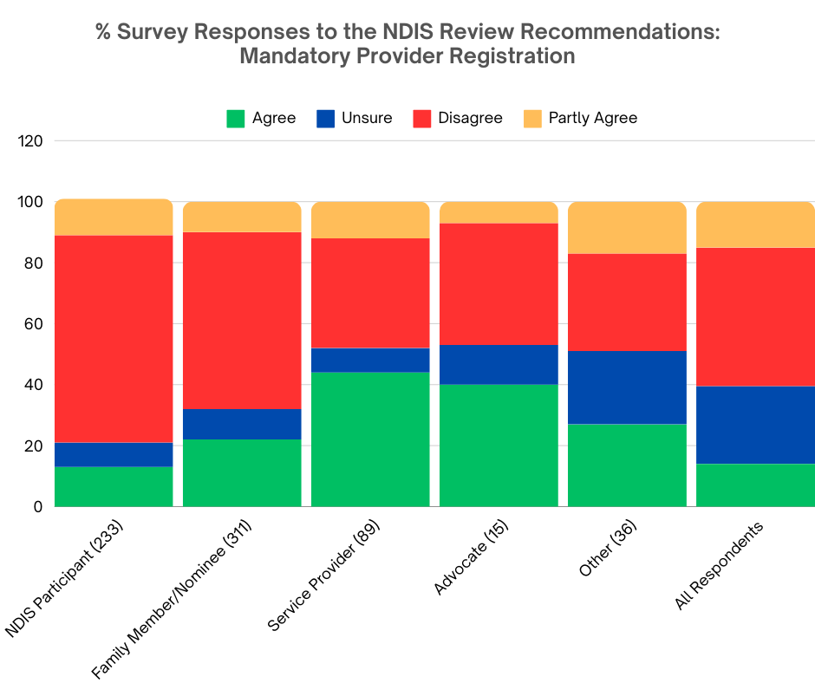

NDIS participants and families had significant concerns with the recommendation for mandatory provider registration as described in the NDIS Review report. Concerns included:
- Losing choice and control over what services participants are able to use.
- Thin markets, and mandatory registration further limiting access to services.
- That provider registration and the NDIS Quality and Safeguards Commission have not been effective in protecting people from abuse.
- Increased costs of support services due to reduced innovation and not being able to use cheaper, mainstream options for support.
- Loss of access to support in regional and remote Australia, where there are minimal or no registered providers.

Some people expressed serious concerns about this recommendation, including fears of a losing all their supports with no benefit, and increased risks and danger due to lack of supports.

“This will destroy all of our current care arrangements and put the participant in extreme danger. Will put an end to self management.” ~ Family member or nominee for a NDIS participant

“Strongly disagree. This removes our choice and control totally. It feels like a removal of human rights.” ~ Family member or nominee for a NDIS participant

Many reported that they would lose existing supports as a result of mandatory registration, and would no longer be able to access unregistered providers as required. Survey respondents stated that the registration process was an additional cost and bureaucratic process, and that unregistered providers would simply stop providing supports to NDIS participants. Others raised concerns that mandatory registration would prevent people from using innovative, low cost and ad hoc support, such as using neighbours or friends for occasional supports.

“I won't be able to use my chosen providers for family members because the cost to register is unreasonable. I also want people who haven’t done the certificate because the course puts all disabled people in the same box and is often incorrect.” ~ Family member or nominee for a NDIS participant

“I have [enquired] of all my supports including my physiotherapist, gardener, support workers if they would become registered providers if this came in. They have all said NO. If forced to use a registered provider I will be left with no supports of any kind.” ~ NDIS participant

“A HUGE amount of providers will choose not to register and we will completely lose choice.” ~ NDIS participant

Survey respondents also raised concerns about negative experiences with NDIS registered providers, leading them to prefer using unregistered providers for their NDIS funded supports.

“Our amazing team of 6 support workers who we recruited have been supporting my family member from 3-10 years. If we were using registered providers they would be changing every six months… Pre NDIS we experienced the inconsistency in quality and reliability of supports who were more focused on promoting their brand than the people they were funded to care for.” ~ Family member or nominee for a NDIS participant

“This would be tantamount to total control over people with a disability, would constitute a total loss of dignity, privacy and choice. Registered providers are invariably large institutions who only care about money and don't offer person centred supports. This removes all dignity, privacy, choice and control and reason to live for people with a disability.” ~ Family member or nominee for an NDIS participant

A great many survey respondents stated in their survey comments that if they were forced to change to using larger, NDIS registered providers, the cost of their supports would increase. Registered providers typically charge the maximum price in the NDIS price guide, passing on the high costs of NDIS registration and auditing to participants. Others raised concerns about privacy, and not wanting all of their providers to know that they are on the NDIS, and still others said that they can buy assistive technology and consumables cheaper from unregistered providers.

“I would be humiliated if all my supports were disability specific as there is no way a mainstream cleaning or gardening business would register for this. I would also no longer be able to access consumables for my needs as many are most affordable from Amazon etc. This smacks of a cash grab by big disability agencies.” ~ NDIS participant

Serious consequences feared by participants in regional and rural areas

People with disability and families living in regional and remote Australia were especially concerned that recommendation of mandatory provider registration would lead to people in geographically isolated areas losing access to support. There are many towns in regional Australia that do not have any registered providers. This is also expected to increase costs in these areas, as registered providers would charge travel costs to support participants in such towns.

“I live in a regional town. There are no registered providers. I use only unregistered providers, and they are excellent. None of them are willing to register, which means that I would lose all my supports. Please, please fight this. This is NOT choice and control!!!” ~ NDIS participant

“Since large providers don’t operate in regional or remote areas this will reduce access to support for disabled people living in the regions.” ~ Family member or nominee for a NDIS participant

Many NDIS participants and families expressed concern that the recommendation would end Self-Management, reducing choice, control and innovation. As stated in the most recent NDIS Quarterly report, 29% of participants and nominees Self-Manage all or part of their NDIS plans, while 62% are Plan Managed. Only 9% of NDIS participants are Agency (NDIA) Managed, showing a clear need and preference for choice, control, and flexibility to use unregistered as well as registered providers.

“I believe that all providers should be registered however I believe that self management should still be an option for participants, where services are being provided by non registered organisation[s] and at the full dignity of risk and choice of the participant to still engage with that service.” ~ NDIS participant

Mandatory registration to increase cost pressures

The NDIS Review’s recommendation for mandatory provider registration or enrolment was seen as a threat to both Self-Managed and Plan Managed participants. These options currently enable participants to choose supports from mainstream or unregistered providers, such as allied health professionals already registered with and regulated by AHPRA but not with NDIS, supermarkets for continence aids, and builders regulated by the Master Builders’ Association. Many people noted their desire for privacy, not wanting to disclose that they had a disability, or that the service they are seeking would be funded by NDIS (eg. cleaners, gardeners, therapists etc). Survey respondents stated that when they advise providers that they are on the NDIS, the cost of supports were frequently increased to the maximum allowed in the NDIS price guide.

“Some people treat you differently and start looking for ways to charge for extras when they know that you are a participant.” ~ NDIS participant

“Being able to use any company with an ABN is the only thing stopping providers from charging the maximum NDIS price every single time. If they know it's through the NDIS the price goes up. Having the choice of any business is important to have choice and control.” ~ NDIS participant

NDIS registered providers were more likely to support mandatory registration

NDIS registered providers were more supportive of the changes. 44% of providers agreed or strongly agreed with the proposed changes. 36% of providers were not in favour of the changes.

The providers who supported the recommendation felt that it would lead to improved functioning of the NDIS, with better quality assurance, compliance, training and accountability. Providers thought that increased registration would help address misuse of NDIS funds and reduce risk to participants.

“It appears to be risk based and a sensible approach to weeding out dodgy providers. Care is required to ensure the cost of the registration process does not limit consumer choice.” ~ NDIS participant

“There needs to be better regulation of people working with people with disability. There are unskilled workers doing what they want, with no accountability. There are support workers simply turning up for their shifts and getting paid but not providing a quality service. There are providers working in areas that they know nothing about, such as mental health. There needs to be a way to monitor the actual service that people are providing.” ~ NDIS Registered Provider

“At the moment unregistered providers get away with a lot with no one [to answer] to. Registered providers are audited and have to have a range of policies and procedures in place. I see too many unregistered businesses being dodgy and committing fraud to vulnerable participants.” ~ Family member or nominee for a NDIS participant

Mandatory registration for some but not all

A view commonly expressed by survey respondents was that limiting supports to NDIS registered providers was only needed where people were especially at risk of abuse, but not needed (or wanted) by all NDIS participants.

“Participants running their plans well are not the ones that need to be protected. Ones being allowed to self manage that don't really comprehend how to use funding is a totally different matter.” ~ NDIS participant

Many survey respondents also noted that there are mainstream bodies already performing a regulatory role, such as allied health providers registered with AHPRA, or builders registered with the Master Builders Association. It was seen as unreasonable for those providers to have to undergo another bureaucratic and costly registration process when already registered with the relevant regulatory body for their profession. Other survey respondents suggested removing the costs and bureaucratic barriers in the current registration system, in order to increase the number of providers voluntarily undergoing the NDIS provider registration process.

“As long as the bottom 2 tiers are free, and the top 2 tiers become less expensive to register. Registration shouldn't be an obstacle, just a process.” ~ NDIS participant

57 survey respondents suggested a different model of provider registration and regulation. Many were concerned that the NDIS Review recommended some form of registration or enrolment for providers of assistive technology, allied health therapies, home and vehicle modifications and repairers. These survey respondents thought that the proposed model could be improved by not requiring registration for these providers, but progressing with other levels.

“If registration were simplified to something like the NDIS worker check then that would be a different story, and I think many of the independent workers would happily do that.” ~ NDIS participant

Survey respondents also expressed concern that the recommendation would not improve the NDIS, and suggested a completely different model of regulation to deal with the concerns about accountability, fraud and safeguarding.

“Maybe there also needs to be a quick, simple way that a person can register a person they want as a support just by nominating them with caveats to ensure they are ok” ~ NDIS participant

Lastly, survey respondents felt that the NDIS Quality and Safeguards Commission and the registration process were unable to prevent violence, abuse and neglect of people with disability. The Commission is already tasked with responding to complaints about both registered and unregistered providers, and the community noted delays of several months in responding to complaints, and insufficient action being taken by the Commission in many cases.

Recommendation 9: Housing and Living Supports

The NDIS Review Report recommends these changes to Housing and Living Supports:
- People who need support 24/7 should be funded at a ratio of 1 support worker to 3 participants, with some exceptions. (see recommendation 9, page 9; see also page 141 for discussion of 1:3 ratio in the NDIS Review Report)
- Funding should assume that supports are shared, except in certain situations (for example, when there is a risk to oneself or others in a shared arrangement, for participants with dependent children, and for those with very complex needs). (see recommendation 9.2 on page 9, recommendation 9.10 on page 10; see also page 141 in the report)
- People could share supports but not share a house. (see recommendation 9.2 page 9; see also page 141 in the report)
- The funding for Housing and Living supports should be separate from the flexible budget. While you can add funds from the flexible budget to Housing and Living supports, you wouldn't be able do it the other way around. (see page 141 of the report for discussion)
- Participants who need 24/7 living supports should get funding to try out new living arrangements before committing to them. (see page 142 of the report for discussion)
- Participants who share supports should get help from a Shared Support Facilitator to have a say in how their shared living arrangements are managed. (see page 142 of the report for discussion)

Survey respondents have voiced strong opposition to these proposals. They argue that the changes contravene the core principles of choice, control and individualised support, elements that have been fundamental to the NDIS's success. There is fear that the recommendations would lead to a regression to outdated practices, negating a decade of progress in disability support that the NDIS achieved.

45% of respondents disagreed or strongly disagreed with the recommended changes to housing and living supports. 15% agreed with some of the changes but not others. Only 14% of survey respondents agreed or strongly agreed with the NDIS Review’s recommended changes to housing and living supports.

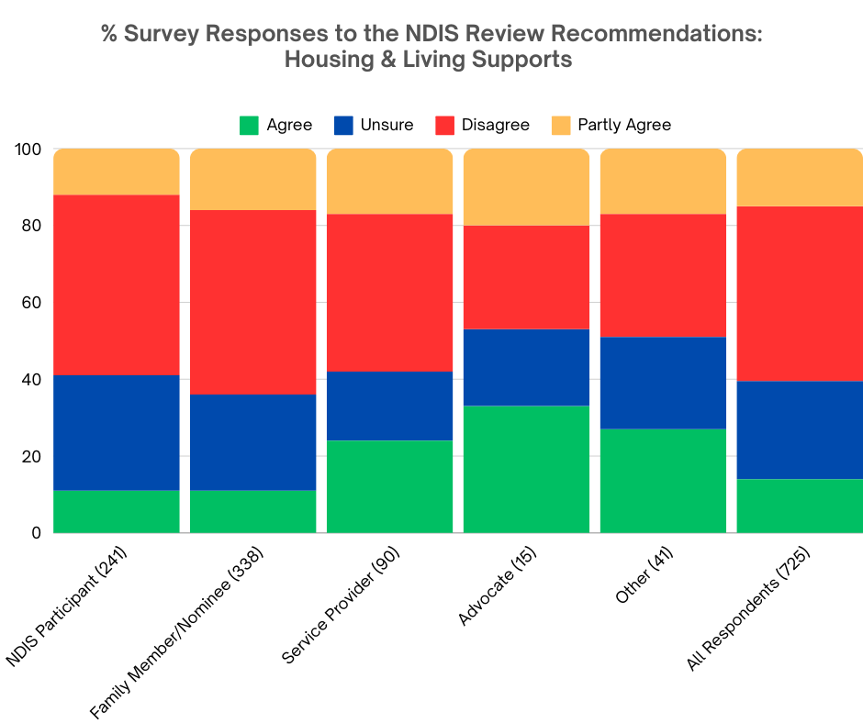

There were high numbers of respondents who expressed negative opinions about the proposed changes to housing and living supports. Many respondents raised concerns about shared supports under a one support worker for three participants support model:

“1:3 ratio is inappropriate and does not uphold the full dignity of the disabled person to live the life they choose.” ~ NDIS participant

“The assumption that all people with a psychosocial disability can be safely and effectively cared for under 1:3 model of support is not only grossly flawed and inadequate but presents a significant risk of harm to our participants and their carers.” ~ Employee of a service provider

There were strong concerns raised among survey respondents that the principle of choice and control was not being respected in the recommended changes. This principle, the core of the NDIS, seems to be at risk according to respondents. A significant portion of the feedback focused on concerns over the recommended shift towards shared living arrangements and a model proposing one support worker for every three participants (1:3 ratio). Many believed that such a move would undermine the autonomy and dignity of those relying on the scheme for support.

Respondents were also concerned that the right to receive individualised support is not protected in the recommended changes to housing and living supports.

“People should be able to get 1:1 support whenever they need it. This is going back to the old days of group housing supports where one person’s needs would be dictated by another’s. Let’s break this cycle which runs every 10-15 years.” ~ Employee of a service provider

“Support needs should be based on individual circumstances.” ~ Family member or nominee for a NDIS participant
Respondents expressed distrust of Government, bureaucracy, and politicians to address the housing and living support needs of people with disability, reflecting on the national housing crisis and extreme shortage of accessible accommodation:

“I wish governments could be more innovative in their thinking. We have a generation of young people and other generations of people who can't find housing.” ~ Other

Survey respondents also raised about the compatibility of these changes with international human rights standards, specifically the United Nations Convention on the Rights of Persons with Disabilities (UNCRPD).

“I strongly disagree that funding is based on a shared ratio and consider that to be a breach of the UNCRPD.” ~ Family member or nominee for a NDIS participant

Survey respondents also raised concerns about the impact of requiring shared support in regional and remote areas, where there are significantly fewer people with disability to share supports with. The community are concerned that this would force people who need 24/7 supports to move away from their families, friends and local community networks to access support.

“Concern also for people who live regionally. Concern that this may push people further into having to live here if you have autism, there if you have physical disability and somewhere else if you have physical disability. Concern for what will happen if there aren’t two neighbours with disability to share supports…” ~ Family member or nominee for a NDIS participant

“I'm concerned about the 1:3 ratio and sharing supports. This is a breach of human rights and will seriously impact people in regional and remote Australia.” ~ NDIS participant

Other respondents raised concerns about losing their privacy and autonomy, when people with disability are forced to reside with others.

“I have lived alone for 22 years and I would be miserable if that changed. I deserve to choose who enters my home and provides care, as well as the people who I live with or accept as visitors to ensure that I feel safe and comfortable. This is my right, and I don't believe that the NDIS should be threatening my autonomy or safety or privacy.” ~ NDIS participant

Questions about the clarity and specifics of the proposed 1:3 support model were also prevalent, with many expressing confusion and seeking further clarification.

“Devil will be in the detail. what does 1-3 actually mean? is it a $ amount?” ~ Employee of a service provider”

“I don’t really understand it.” ~ Family member or nominee for a NDIS participant

A small number of respondents (only 14 percent) agreed or strongly agreed with the recommended changes to housing and living supports. This is reflected in the comparatively low number of comments expressing positive opinions about the proposed changes in our survey. Some respondents expressed support for funding and opportunities for people with disability to trial different living arrangements before committing to a specific model of support or provider.

“I agree that there should be funding available to trial different housing options.” ~ Employee of a service provider

“I agree that funding to try out arrangements is important.” ~ Family member or nominee for a NDIS participant

“I agree participants should get funding to trial new living arrangements before committing - this would enable more choice and prevent clogging of resources, funding and time with repeated reviews for changes.” ~ Family member or nominee for a NDIS participant

Some respondents saw potential in a more flexible and sustainable funding model for housing and living supports:

“Certainly, I agree that funding should be more flexible.” ~ NDIS participant

“These changes may be ok and I understand why to save costs in some circumstances.” ~ Family member or nominee for a NDIS participant

Finally, respondents gave support for greater flexibility of home and living options while retaining choice and control:

“I agree that there should be a much greater range of home & living options for people.” ~ Employee of a service provider

“I want my daughter to feel safe in an environment of her choosing and to be supported in the way she decides.” ~ Family member or nominee for a NDIS participant

Recommendation 4: Navigators

The NDIS Review Report recommends Navigators, who would:
- Support all people with disability to navigate mainstream, foundational and NDIS systems.
- Assist people before they access the NDIS, through proactive outreach and support.
- Replace Local Area Coordinators, Early Childhood Approach Coordinators and Support Coordinators with Navigators available to all people with disability. People would not have funding for Support Coordinators in their NDIS plans but would be able to access Navigators as required.
- Be provided in local communities, with a nationally consistent framework by people who have good local knowledge and connections.
- Include Specialist Navigators qualified in allied health or social work, with lower caseloads, working with participants who have more complex or specific needs.
- Support participants to use their NDIS funding and check-ins.
- Be appointed by and funded (separate to NDIS plans) by the government following a Tender process. Organisations would apply to provide Navigator services, and the government will choose the organisations that deliver this service.

See recommendations 4.1 to 4.4 on page 7 of the report.

42% of survey respondents disagreed or strongly disagreed with the recommendation for navigators, and 20% were unsure about the proposal. A further 14% agreed with some of the changes but not others, and 23% were in favour of this recommendation.

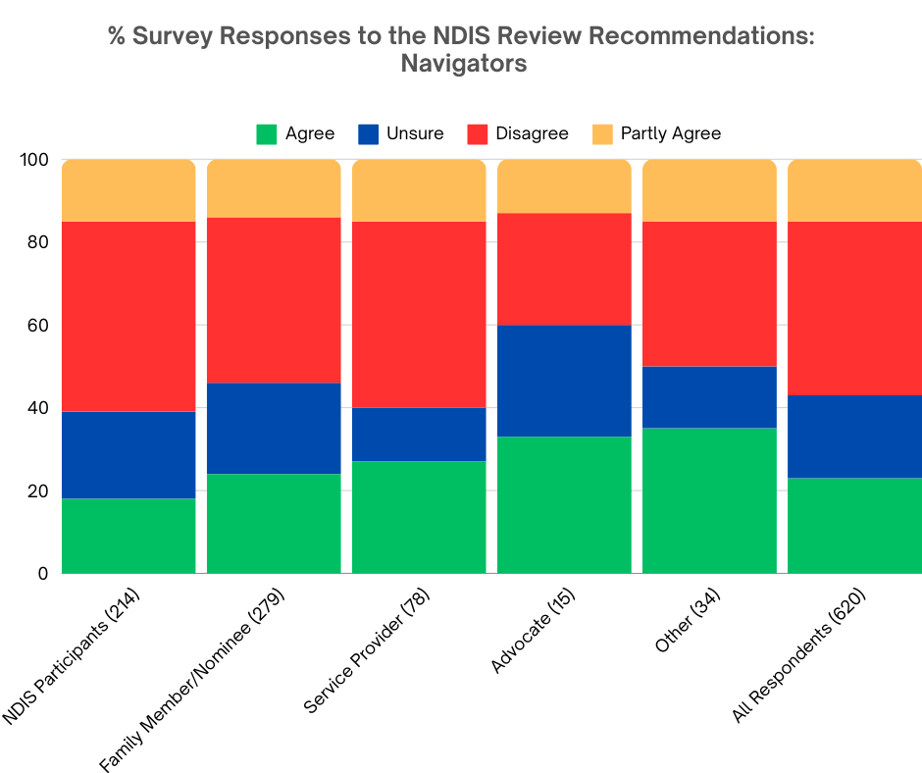

In response to the question “What do you think of Navigators?”, we received 348 comments. Generally there were significant concerns about how the recommendation for navigators would be implemented. Many respondents were anxious that “Navigators” would simply be a rebranding of the existing Local Area Coordinators (LACs). Others expressed doubt that the implementation of navigators in the sector would be successful, sufficiently funded, and provide the high level of navigational support that people with disability need.

There was confusion and concern expressed about the loss of Support Coordinators, with whom many participants and families have built rapport, trust, and a supportive relationship.

Respondents were worried about how navigators would be rolled out, especially with regard to the tender process. Many saw the tender process as flawed, likely to select the existing large organisations currently providing services in the disability sector, particularly those with existing Partner In The Community contracts. Respondents were also concerned that the tender process would remove individual choice and control, a key feature of the NDIS.

Concerns about the workforce were raised, with respondents questioning what skills, qualifications and experience potential navigators would have. Questions included where such qualified workers would be found, in a sector where there are already thin markets and workforce shortages. Many respondents asked why navigators would be restricted to staff with allied health or social work qualifications, when there are people with lived experience who would make excellent navigators, and there is a national shortage of allied health professionals which would not be addressed in the 5 year time frame proposed by the NDIS Review for rollout of their recommendations.

“Again in theory a good idea. Where and when will these people be trained and ready? How will you find enough people and train them in all aspects of disability and personal needs? What happens when (Shock/horror) there are not enough navigators?” ~ Family member or nominee for a NDIS participant

“Not a fan of losing support coordinators. To me, this change would increase the workload considerably for navigators, and they are unlikely to be able to provide timely support. However, it would be good to have this sort of assistance available to those outside the ndis.” ~ NDIS participant

“I would like assurance that the people in these roles have the relevant qualifications to do this job. I’ve had far too many LACs who are literally there for the paycheck and little to no empathy for participants or their families.” ~ Family member or nominee for a NDIS participant

“Include Registered Nurses Specialist Navigators , with lower caseloads, working with participants who have more complex or specific needs.” ~ Advocate

“More details needed. Worry where they will find these people. Worry about independence from NDIS.” ~ Other

“Not happy with no independent Support Coordinators. Also concerned with knowledge, training, access and availability of these navigators.” ~ NDIS participant

Survey respondents expressed concerns about the lack of co-design with and inclusion of people with disability in the proposed recommendation of navigators.

A common theme in survey responses was that the current system of Support Coordinators either works well and/or requires minimal tweaking, rather than complete systemic overhaul as recommended by the NDIS Review.

As previously noted, 42% of respondents disagreed or strongly disagreed with the recommendation for navigators, and this is reflected in the high quantity of comments which expressed negative opinions about the proposed changes.

Many respondents gave examples of how the current system of individually chosen Support Coordinators works well for them and expressed distress at losing their Support Coordinators.

“And destroying Coordinator roles which are working well is good because? Stupid. Of course everyone should have access to help and coordination as necessary however getting rid of roles in people's plans when they're working is stupid.” ~ NDIS participant

“Support Coordinators essential part of NDIS assists to find services and assists with any issues with services.” ~ Family member or nominee for a NDIS participant

“My experience with my Support Coordinator has not only kept me alive in terms of accessing support but also knowing me and my needs well. My experience with NDIS has been challenging and really traumatic as well as with the LAC large organisations running these navigator roles would be incredibly detrimental to participants and once again does not take into account what we as people with disability need.” ~ NDIS participant

“We have a good Support Coordinator, who is getting things done. If it ain't broke, don't fix it!! I thought the NDIS was based on Choice and Control, where does that come in if we have to accept a Government appointed Navigator?” ~ Family member or nominee for a NDIS participant

Interestingly, there was very little support for keeping LACs. Only one respondent said that the end of Early Childhood Approach (ECA) Coordinators would be a great loss for families of young children in the NDIS.

“I want to see the support coordinators position kept as these roles support the person with a disability and their family. We deserve support that feels safe and that appears to be on our side.” ~ Family member or nominee for a NDIS participant

Some survey respondents also voiced concerns about having to tell their story again and again, rebuilding relationships with new staff – a process both exhausting and often traumatic.

“This [doesn’t] work with LACs, they are not independent, many will be poorly trained and inexperienced and why change from Support Coordinators who have built up a body of knowledge and experience. Potentially you would get a new person frequently who wouldn’t know you or the PWD. Exhausting telling the story, building their knowledge and lack of choice and control – again.” ~ Family member or nominee for a NDIS participant

“LACs were supposed to fill this role. But with no training are not fit for purpose. My SC [Support Coordinator] knows me and my requirements. I do not have to retell my story and needs to my SC (and run risk of being misunderstood).” ~ Family member or nominee for a NDIS participant

“Many people benefit from having a Support Coordinator. It doesn't sound like a navigator would provide the same role and that this person may change (via tender changes) preventing other from retaining a Support Coordinator who they work well with and trust. Potentially needing to change and retell their personal stories to news people far more often than is necessary.” ~ Family member or nominee for a NDIS participant
Many were doubtful that the recommendation would be effective, with some commenting that given past experience (eg. the NDIS Partners In The Community), it was unlikely that navigators would be successful in achieving the support to understand and navigate disability and mainstream services that people with disability need.

“I think it’s more of what’s been tried before and failed. Navigators can’t change the culture in mainstream service systems. The first thing needing to change is the skill level and attitudes of mainstream front line and management for more inclusive practices. There’s loads of tokenism and our lived experience is that mainstream providers still see people with disability as too much effort when they are already stretched trying to provide to others. Navigators won’t change that.” ~ Family member or nominee for a NDIS participant

“Just the same story by another name that’s what LAC's were supposed to be for and no matter how many times I asked for a support coordinator they wouldn’t even ask NDIS for it. So you will please excuse my being skeptical.” ~ NDIS participant

Notably, a significantly high number of survey respondents said that Navigators was just a new name for LACs, and questioned what difference there would be.

“How is this job description different to the original inception of local area coordinators?” ~ Employee of service provider provider
“In principle, I agree but am unsure about this proposal and the differential points from existing LAC and support coordination.” ~ Family member or nominee for a NDIS participant

“It’s extremely unclear how this differs from plan management and support coordination”. ~ NDIS participant

The NDIS Review suggested that navigators would provide support to all people with disability under the age of 65 years to navigate mainstream, foundational and NDIS systems. Several respondents expressed concerns that the proposal for navigators would likely be unsuitable for supporting people with severe and complex disabilities.

“Support Coordinators are key for complex needs. Navigators sounds like a fancy renaming of Local Area Coordinator. One size doesn't fit all.” ~ NDIS participant

“The lack of case managers and coordinators because of the role of the NDIS has led to many people with disabilities and complex needs to be left alone without support, and more often [than] not are highly dependent on their Support Coordinator to advocate and support them in times of crisis or other complex needs, especially if that person has severe intellectual or autistic impairments and has no other informal supports capable of assisting them. It is also not realistic or fair to force people to lose the workers that they already trust and have good relationships with. It will also lead to mass loss of unemployment and loss of good knowledge and experienced workers. While some ideas are good it will have long term practical and logistical issues especially in rural and regional areas.” ~ Family member or nominee for a NDIS participant

“I see the value if this is done well for both guiding new applicants through a confusing process and the ongoing safeguarding of participants, especially those with cognitive disability and no family or close friends and advocates.” ~ Family member or nominee for a NDIS participant

The recommendation for navigators in the NDIS Review report was not well understood by survey respondents, who were seeking more information, such as:
- Whether participants would be able to choose their navigator or “be lumped with someone such as it is for now for partner organisations” (Family member or nominee for a NDIS participant).
- Why navigators have been recommended when LACs and Support Coordinators are already operating. People wanted clarification on whether there a cross over between plan management and support coordination?
- Whether navigators would charge for services, in the way that the current system of Support Coordinators do.
- How much funding would be available to participants in their plans to purchase navigator services.

It’s clear that more information is needed for the community to understand how navigators would differ from the current system of individually chosen Support Coordinators, Psychosocial Recovery Coaches, LACs, and ECA Coordinators.

Some survey respondents were concerned that the recommendation would put navigators at the centre of the NDIS, rather than people with disability.

“Will navigators be imposed on every person with a disability. What is their role definition? Seem to have SIGNIFICANT roles and power as articulated in the report. Is the role a cross between plan management and support coordination OR is it just old fashioned case management under a new name. The Navigators seem to be at the centre of the NDIS now and not people with disability. How many navigators will be in people's lives? Many different area navigators are suggested in the report.” ~ Family member or nominee for a NDIS participant

“The proposal places navigators rather than disabled people at the centre. Disabled people and their families are the experts in this area.” ~ NDIS participant

The recommendation for navigators in the NDIS Review report suggested that they would be provided in local communities, with a nationally consistent framework. Respondents wanted more information about how this would be implemented, especially if they were to be selected by Tender, as recommended in the report. It was the Tender process which raised the most concerns from survey respondents, fearing that navigators would be a repeat of the failures of the LAC system, where providers were selected via Tender.

“All I see is LAC PITC [Partners in the Community] losing their name and changed over to navigator and again will see the tender go out with the same big companies winning. LACs should of went years ago. What will happen in rural areas. Keep the Support Coordinators play. They play an important part in the NDIS.” ~ NDIS participant

“It would be the same problem as LAC. Don’t know who my LAC is. The only time I hear from them is plan review time. They have no knowledge of what I need.” ~ NDIS participant

“Navigators just sound like LACs with more responsibility. The current LAC format has overworked and understaffed offices. In my family there are three NDIS participants and we have never had any consistency or felt like we were understood.” ~ NDIS participant

Survey respondents expressed concern that the Tender process could lead to conflicts of interest. Potential issues raised included:
- The tender process is likely to prioritise larger provider organisations; excluding smaller, innovative organisations and sole traders with local knowledge and disability-specific expertise.
- Organisations who provide navigators should not be able to be NDIS service providers as well.
- How the proposed navigators would ensure that all people with disability would be supported, and promote inclusive, safe and diverse services.
- The tender process would reduce participants’ choice and control.
- How the organisations providing navigator services would be selected, and what the contracts would stipulate.

“The idea of the navigator role is great (aka Support Coordination), but I do not think it should funded by a government tender process. I strongly disagree with the tender process. This would be a key role, so Navigators must not be assigned or allocated to participants. Participants must be able to find a navigator who they can easily work with / communicate with, in the same way that they can find a support coordinator who is a good match for them now.” ~ NDIS participant

“The tender process would result in the lowest bidder getting the job which invariably means the lowest form of support. GIVE PEOPLE CHOICE AND CONTROL!!!!!” ~ Family member or nominee for a NDIS participant

“Very concerned this will end up being just the same orgs as we have for LACs - which are consistently dreadful.” ~ NDIS participant

“It feels like groundhog day, how many times do people and their families need to recreate relationships and tell their stories so that they can access the support and services they need. How will this ensure that people in rural and remote and CALD communities receive the supports they need and not be left behind? The same for hard to reach participants who don't have access to technologies.” ~ Family member or nominee for a NDIS participant

One of the key objectives of the NDIS is to enable people with disability to exercise their choice and control over their lives and their supports. Notably, survey respondents expressed significant fear that their choice and control would be diminished by the recommendation for navigators. There were almost 80 individual comments expressing concern about the risk to choice and control.

“No No NO Loss of Choice and Control. This is totally de-humanizing the system, worse then it is now. Support Coordinator is my sanity, my daughter's constant in this system, her knowledge base I an aging parent with terminal health issues.” ~ Family member or nominee for a NDIS participant

“I don't see how Navigators can have the extensive knowledge of every disability and living situation to be able to make serious decisions for people's lives. Where's our choice for our life? Coordinators advocate and have a personal relationship with their clients. This trust has been built up over years. The recommendation is to rip that away taking away our choice, freedom and safety. Navigators will be employed directly by the NDIS making a huge conflict of interest. The tender system did not work for LACs there is no reason it will work for navigators.” ~ NDIS participant

“I have deep concern about taking away support coordinators who sit independently of the NDIS who help advocate for their clients to receive the correct fund for supports they need. I don’t see how these “navigators” employed by the NDIS will do that???” ~ NDIS participant

“Our support coordinator has been a[n] integral & invaluable part of our family members management having to negotiate & liaising between 2 failed Disability Support Services who both failed to provide adequate care of family member.” ~ Family member or nominee for a NDIS participant

“This is not feasible and removes the choice for participants to engage support providers they wish to work with. It also generalises the individual needs of participants.” ~ Employee of service provider

“The idea is good, but tendering out removes choice, and means that participants with low incidence disabilities are at the mercy of personnel who do not know their situation.” ~ Employee of service provider

“I do not think that the government should be dictating who delivers the navigator services. This should be the choice of the person with a disability.” ~ Employee of service provider

Benefits to the recommendation and possible alternate models

In the positive commentary about the proposed introduction of navigators, the main theme was that the current Partner In The Community system of LACs is not working:

“Current system is not helpful and navigators if trained well and monitored could solve this.” ~ NDIS participant

“Everyone should be able to access this unlike now with not everyone getting SC [Support Coordination] funding.” ~ Family member or nominee for a NDIS participant

“I agree with the notion of 'navigators' to help reshape what has been the market position of LACs / SCs & Plan Managers. I believe it is important to make sure that the tender process supports the appointment of locally based providers - NOT just the big national providers. Experience of LACs partner services shows these types of services have been ineffective and long wait lists. Appointment of navigator services should be based on knowledge, skill and capacity not just being easier for DSS to contract manage 5-6 large national providers – local[ledge] know and local connections will be key for the success of these roles.” ~ Employee of service provider

“If they can get it right, this might work. The current process of using LAC’s is a mess! The turnover of staff is high and continuity of care does not exist. I guess they have to try something new. The thing is, can they do it and get it right!” ~ Family member or nominee for a NDIS participant

Survey respondents commonly expressed that for this recommendation to be successful, it must be co-designed with people with disability. Ideally, there “should be a preference for lived experience navigators” (employee of a service provider).

“Navigators have the potential to improve access for the group of people that the NDIS is targeted towards. Who need help with improving accessibility.” ~ Family member or nominee for a NDIS participant

“This could be a wonderful service if utilised appropriately. The NDIS is a huge beast for unfamiliar and uneducated participants and their families to navigate.” ~ Family member or nominee for a NDIS participant

Recommendation 3: Eligibility and Access

The Independent NDIS Review recommends a lot of changes to eligibility and access to the NDIS, including:
- Focus on significant functional impairment and needs, rather than medical diagnosis.
- Removal of the Eligibility Lists.
- Removal of primary and secondary disability.
- Functional Impact Assessment covering a broad range of domains (e.g. cognitive, language, social-emotional, motor and adaptive behaviour) to decide eligibility.
- Functional assessment completed by person’s treating professional, funded by the Government.
- Simplify Access Request and Supporting Evidence forms, with guidance on how to apply.

See recommendations 3.1 to 3.6 on page 6 of the report.

48% of survey respondents agreed or strongly agreed with the recommended changes to eligibility for and access to the NDIS. A further 20% were unsure about this recommendation, while another 20% disagreed or strongly disagreed with the recommendation. 12% of respondents agreed with some of the changes but not others.

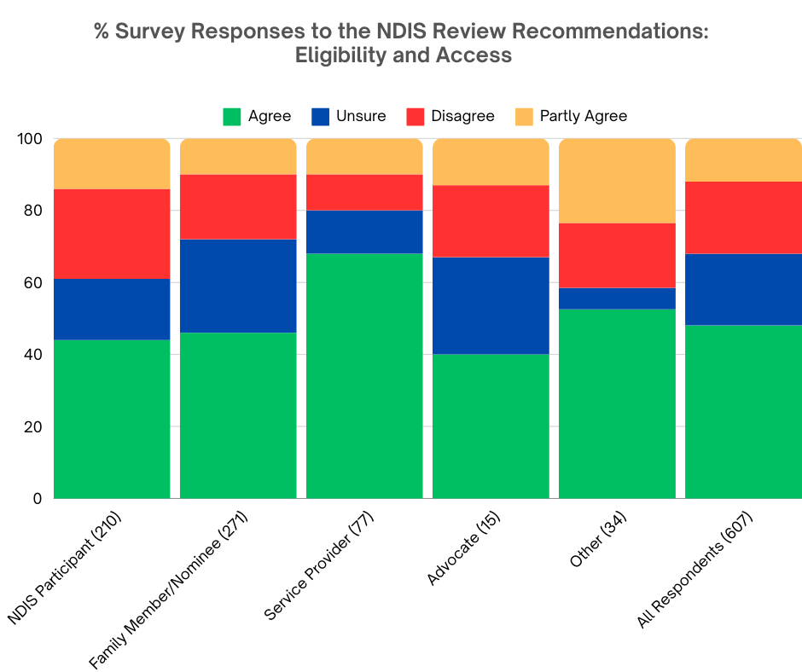

248 survey respondents commented on the question “What do you think of the suggested changes to eligibility and access?”. Overall, there was support to the proposed changes to eligibility for and access to the NDIS, however two common concerns were expressed. Firstly, that the “devil is in the detail” reflecting that respondents have significant concerns about how the changes would be implemented, and uncertainty about its effectiveness. Secondly, respondents noted that “one size does not fit all”, referring to the diversity and complexity of the disability community.

The high standard of the insights and commentary from EAC community in this survey emphasised the importance that Government include people with disability in the co-design of any changes to eligibility and access to the NDIS.

The recommendation suggested that eligibility focus on significant functional impairment and need, rather than medical diagnosis. There was the most commentary from survey respondents about this aspect of the proposed change to eligibility and access.

Overall there was support for the proposed recommendation to focus on significant functional impairment and needs, rather than medical diagnosis. Many survey respondents thought that the recommendation would aid in bringing the NDIS back to its original purpose:

“The NDIS was always supposed to be function based not diagnosis based.” ~ NDIS participant

“Generally agree. My understanding is that it was always supposed to be about functioning, not diagnosis.” ~ NDIS participant

Respondents also noted that access to the NDIS should not be a “tick box” exercise.

“NDIS must be about function rather than medical definitions which require people to fit in boxes. Supporting people to enjoy better lives means respectful assessment of individuals by professionals they’re known by and trust.” ~ NDIS participant

Some respondents stated that functional impairment is more relevant than medical diagnosis for eligibility and access to the NDIS:

“Functional impairment is far more accurate than diagnosis in determining support requirements. Not relying on diagnosis will also speed up participants access to NDIS and also reduce costs.” ~ Employee of a service provider

“It should be based on functionality and ability to carry out ADL [Activities of Daily Living], not diagnosis.” ~ Person with disability not on NDIS

While 48% of survey respondents agreed or strongly agreed with the recommendation, there was uncertainty expressed in the comments.

“I fully support being able to access support without a formal diagnosis. That system has prevented many people from accessing it who really need it. However I worry that there will still be too many hurdles to overcome for people who don’t have the capacity to clear them.” ~ Family member or nominee for a NDIS participant

Too many questions about how the recommendations would be implemented remain, which is increasing anxiety in the community.

“Many questions. How is diagnosis and permanence decided? Will the recommendations of treating professionals be binding on the NDIA for access? Will the functional capacity assessment be sufficiently detailed and based on person-to-person contact (preferably in the home)? Will it be given enough time to really get to know the participant and family's actual lived experience? Will the recommendations be binding on the NDIA in the decision making and planning process?” ~ NDIS participant

Many people raised concerns about how many assessments people with disability would be required to undergo, and how often those assessments would be required.

“This is a good change. It should be done with the people that are already involved in their care and know them well. It should not be required every year or two years to "proved" they are still disabled. A good plan should be able to be set up and rolled over with notification when things change for the person and a simple process to have this happen. This should be co-designed with people with a disability. This "primary" disability has caused insurmountable problems and was wrongly rejected by the NDIS, after following what they said to do! It was then shown by them to be wrong but they refused to fix it I had to keep jumping through hoops and trauma and stress. People should be able be intimately informed if they are going to give guidance on how to apply, not just learn a script! Trauma Informed.” ~ NDIS participant

“Functional assessments are far too frequent and can sometimes be distressing for the person with a disability. They are also a huge waste of government money. NDIS is meant to be for people who are impacted by long-term disability and so why the need for such regular functional capacity assessments? If something has significantly changed in someone’s life then that is understandable but otherwise not.” ~ Employee of a service provider

“Eligibility lists for some rare Syndrome’s such as Angelman Syndrome make sense as there is enough evidence to know that they will all require supports. Their inclusion into the scheme should be automatic and followed up with a functional assessment that can be put in context with the disability/syndrome they have. These families do not need the extra stress of having to fight to get access to support.” ~ Family member or nominee for a NDIS participant

“I agree with allowing functional assessments to gain access for complex disabilities eg those with a genetic syndrome without a diagnosis, rare diseases etc. However, asking to assess some people where they likely have many previous assessments before is exhausting. It should be either diagnosis/or functional assessment, not just one.” ~ Family member or nominee for a NDIS participant

“And people should not have the trauma of having to continually justify their disability support needs when the disability is identified as permanent.” ~ Family member or nominee for a NDIS participant

“Functional assessments are already completed as part of the NDIS assessments (e.g. a Vineland-3 or PEDI-CAT); how many of these are required[?]” ~ Family member or nominee for a NDIS participant

While in favour of the recommendation, respondents expressed concern about the potential conflict of interest regarding the independence of the people performing the functional assessments used to determine access eligibility.

“This sounds like a great proposal, in regard to streamlining services and ensuring people with functional deficits can access NDIS regardless of a diagnosis. It also sounds like it could remove hurdles to diagnosis in underprivileged communities due to not being able to afford assessments. However, when treating professionals are completing a Functional Capacity Assessment for their clients, they have a direct conflict of interest. They are completing reports stating clients REQUIRE 'x' amount of sessions, at 'x' price. How do we ensure that they are not just padding own pockets, and creating more clients for themselves?” ~ Family member or nominee for a NDIS participant

“Agree that funding should be on functional need not diagnosis but concerned about skills and independence of assessors and equity of access to the scheme.” ~ Interested person

“Assessing functioning needs to remain in non governmental hands and not placed in hands of assessor’s influenced by government agenda. It needs to remain the choice of participants as to who they allow to assess them. Otherwise the NDIS may as well be called Centrelink disability insurance scheme.” ~ Advocate

“I have huge concerns that the assessor will be an agent or employee of the NDIA. This is a significant conflict of interest, and past experience has proven to participants that the burden of responsibility is on them to justify and fight for adequate funding levels from the NDIA. The anxiety of this can be extremely traumatic, with many participants and/or their families dreading any process where the NDIA is reviewing their support needs. They are often left disillusioned at the huge gap between the NDIA assessor’s perception/assessment and the participant’s lived reality, which is often also reflected in their primary care provider’s assessments and reports.” ~ Family member or nominee for a NDIS participant

It's important to note that many respondents disagreed with the recommendation for functional impairment rather than medical diagnosis for eligibility and access to the NDIS.

“Some medical diagnoses cause lifelong impacts/ disabilities - this is splitting hairs. Eligibility lists are both positive and negative- great if you are on the list, problematic if you are not. Multiple disabilities need to be included, failure to recognise co morbidities is a huge issue. What if you don't have a treating professional - this is putting costs back onto families for the initial appointments. Simplifying access is a good thing. Should be combined with simpler and quicker ways to advise when more supports are needed.” ~ Family member or nominee for a NDIS participant

“It is very confusing accessing NDIS as it is based on function and effect rather than medical. A doctor when writing a report will of course base it on medical because that is what they are trained for. Oc[cupational] Therapists are also a rip off and take advantage of the system. I have had 3 reports charged thousands most was cut and pasted off the internet and no follow up told they could not come out anymore because of where I live.” ~ NDIS participant

“Again this is very unclear. To not fund based on diagnosis seems discriminatory and immoral. A diagnosis means there IS a disability and therefore requires funding to assist.” ~ Family member or nominee for a NDIS participant

“This is designed to keep the autistics and folks with psychosocial disability out. Discriminatory.” ~ Family member or nominee for a NDIS participant

One respondent suggested a “hybrid arrangement”, and many others described the same concept – disability is not always clear cut and sometimes you need to consider both functional impact and medical diagnosis, and there are certain medical diagnoses that should remain automatically eligible. Being required to undergo additional assessments in addition to diagnosis can be extremely overwhelming and traumatic for some people.

“Concerns about the first dot point [focus on significant functional impairment and needs, rather than medical diagnosis]. Sometimes a Medical Diagnosis and Functional Impairment go hand in hand and can be intertwined. There needs to be equal weight given to both I think. Everything else we agree with, particularly the Functional Assessment being given by the Participant's treating Professional.” ~ Family member or nominee for a NDIS participant

“If a diagnosis is received, surely that shows some functional impairment and needs? I agree one diagnosis is not same impact on different people, but some baselines have to be accepted. Disregarding medical and DSM-V [Diagnostic and Statistical Manual of Mental Disorders Version 5] diagnosis is limiting. And seems a bit dismissive of trained professionals. I think a dual approach is better here. Diagnosis with functional assessment as well.” ~ Family member or nominee for a NDIS participant

“It is difficult. I think the mix is important. The current algorithms and planner experience seem often to overlook the extreme functional impact of secondary disabilities and medical condition which often are secondary to the primary.” ~ Employee of a service provider

A major concern expressed by many NDIS participants and family members is that functional assessments are merely Independent Assessments 2.0 except no longer independent. These concerns focused primarily on who would be performing the assessments, whether they would be independent from g]Government, who would pay for the assessments, and lack of choice and control:

“Sounds like independent assessments being snuck in under disguise.” ~ NDIS participant

“Omg independent assessments version 2!” ~ Family member or nominee for a NDIS participant

“This appears to be a new name for the independent assessors which was not received well and stopped. Who will be in charge of these assessments? We have seen functional capacity assessments been delivered by experienced and skilled mental health social workers being denied for participants with a psychosocial disability by LACs and planners - this is not in the legislation or code of conduct. How will this process ensure that bias towards appropriate and trained professions doesn’t occur?” ~ Employee of a service provider

“This is just the government's way of implementing Independent Assessments, and they are only doing it because they think it will decrease the number of future participants. If the NDIS currently ignores therapist and assessment report recommendations, why will this change in the future? It's ridiculous to only base eligibility on assessments.” ~ Family member or nominee for a NDIS participant

“Re: removal of primary & secondary disability is good. Having just one or 2 disabilities listed is limiting. But doing independent assessments is bad. How well will they be trained.” ~ NDIS participant

“I don't really know enough to know if these will be beneficial or negative changes. I do know if this is a way of bringing back independent assessments in disguise it will be a disaster. There is a reason why the community campaign against them a few years ago.” ~ NDIS participant

“Isn’t this independent reviews again? So many painful questions about my life?” ~ NDIS participant

While most survey respondents agreed that functional assessments should be completed by the person’s treating professional, many questioned how that would be possible when there are severe workforce shortages and retention issues in the disability sector. Our community are concerned that the shortages of qualified staff would increase already extensive wait times to see professionals.

“Getting a functional impact assessment at the moment takes about 2 years - and that's when you're already a participant. Workforce shortages in regional areas make this an unrealistic proposition, and increases anxiety around not having access to regular specialists who know our abilities. It reeks of Independent Assessments all over again.” ~ NDIS participant

“I agree with point 1 2 and 3, however when there is a significant OT [occupational therapist] shortage especially in remote and rural areas and the first NDIS funds will only allow for a FCA [Functional Capacity assessment] instead of immediate supports is not helpful. Also OTs will charge [$]8k for a FCA because they are the only pediatric OT in the region. This is an abuse of NDIS funds. I would rather the NDIS listen to what the family is experiencing and understand that when they say the family is crisis, they need to listen and step in and support. Just telling me that I need an OT to tell me what's wrong with my kids so the NDIS have more diagnoses to be eligible for more funding for support is not helpful, if anything is add additional stress to the family unit who are just trying to keep their kids alive.” ~ Family member or nominee for a NDIS participant

“There is a risk of an over reliance on medical and allied health staff in the proposed strategy ... and what we know is that there are simply not enough of these professionals available to meet demand in a timely manner ... especially in rural and regional areas.” ~ Employee of a service provider

“The assessments will be done by OTs I'm assuming. The OTs are already swamped. Psychologists, who would do mental health functional assessments, are so full most have their books closed in SA.” ~ NDIS participant

There was a split in responses on whether only Occupational Therapists should perform the assessments, or a range of professionals. As stated above, the lack of qualified staff in the sector is seen as a significant barrier to the successful implementation of the recommended changes to eligibility and access. Respondents also raised concerns about the skills of assessors; understanding of the person’s disability; and whether Occupational Therapist would be the most appropriate professional to carry out the assessment. These comments emphasise that ‘one size does not fit all’ when it comes to people with disability, and vitally that the core of the NDIS is choice and control over who completes any assessment.

“GP's should be able to make this call not wait for paediatrician or specialist who does not know the person. Totally agree!!” ~ Employee of a service provider

“Agree with most except the functional assessment, due to not capturing certain disabilities accurately, secondly they can be skewed based on how the individual is presenting on the day. Some participants may have better reports from other services e.g., psychologist or physiotherapist, by having a FCA [Functional Capacity Assessment] be mandatory it could create more of a financial strain and complications for those who do not have a rapport with an OT.” ~ NDIS participant
“Long overdue. Brilliant plan. MUST be assessed by Occupational Therapists and Psychologists however, as these are the allied health professionals with the skills, qualifications, registration requirements, ethical standards of practice required to conduct such assessment of functioning (and not Social Workers who are not trained in the assessment of physical or psychological functioning).” ~ Family member or nominee for a NDIS participant

“Subjecting people to constant assessments by people with no real knowledge of the person is dehumanising.” ~ Family member or nominee for a NDIS participant

“As long as the Functional Assessments are completed by the person's treating doctor and funded by the government that would be good. NO to government assessors. And it would be good to get rid of having to obtain the assessments from an OT who only meets with you for 1 hour. Your treating doctor knows you the best.” ~ NDIS participant

“Diagnosis is important as well as functional assessment. But functional assessment should be on standard forms but with therapist who know the participants, not just rolled through as a number.” ~ Family member or nominee for a NDIS participant

In general, there was overall agreement to the NDIS Review’s recommendation that the NDIS Access Request and supporting evidence forms be simplified. There were no negative comments about this proposal.

“Great that they are looking at simplifying this process. Must make the eligibility criteria clear, public and transparent.” ~ Employee of a service provider

“I believe that any eligibility and access changes that will stop 'assessors' from exploiting the NDIS by massively inflating the charges to undertake eligibility assessments would be excellent. Perhaps the suggested changes would help to reduce the very long waiting times for applicants.” ~ NDIS participant

“The access process needs to be simplified. Participants should be assessed by appropriate professionals of their choosing. Assessments should be funded.” ~ NDIS participant

“Yes, agree that the eligibility process needs to be simplified and removal of primary and secondary diagnosis. There needs to be clearer guidelines and feedback regarding functional capacity assessments i.e., provision of templates so that system is streamlined and reduces cost of assessments. Functional assessments should be completed by appropriate allied health professionals whose scope it is to assess theses domains of function - Occupational Therapists. Other Allied health professionals do not receive the scope of training and education to be able to comprehensively assess these domains.” ~ Employee of a service provider

Recommendation 6: Early Intervention

The NDIS Review Report recommends changes to how early intervention would work. Some supports would be through Foundational supports, some would be through NDIS.

Early Childhood (under 9 years) changes include:
- Expand child development checks to identify children with developmental concerns and disability, and link to early intervention.
- All children aged 0 to 9 years to enter the NDIS under early intervention requirements, rather than permanent eligibility.
- Early intervention capacity building supports for children based on best practice principles and evidence.
- Supports guided by a lead practitioner (key worker), and delivered in homes, early childhood settings and schools wherever possible.

See recommendations 6 to 6.7 on page 8 of the report.

Psychosocial Disability changes include:
- Early intervention pathway for most new participants with psychosocial disability.

See recommendation 7.1 to 7.6 on page 8 of the report.

39% of survey respondents were in favour of the changes to early intervention proposed in the NDIS Review report. A further 31% said they were unsure about this recommendation, while 17% disagreed or strongly disagreed. 12% of survey respondents agreed with some of the changes, but not others.

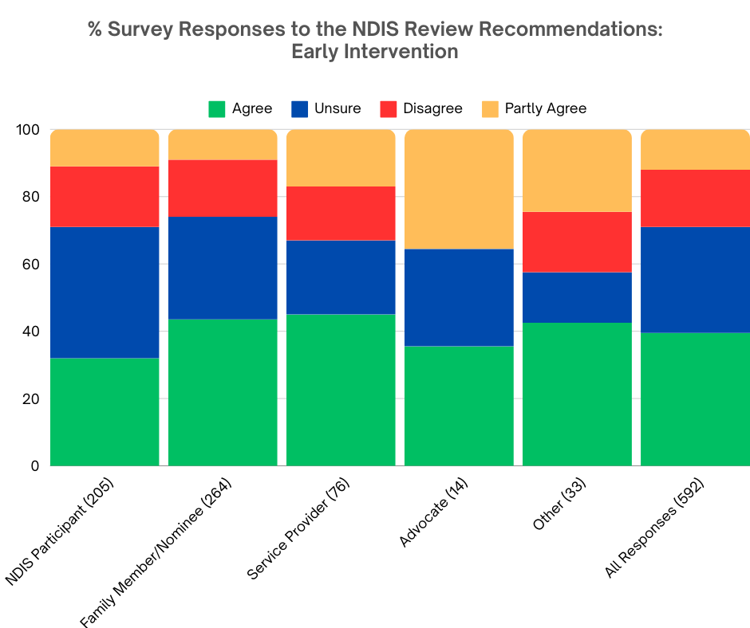

In response to the question, ‘What do you think of the recommended changes to early intervention?’ there were 193 comments. Positive opinions were expressed by survey respondents, showing
- in principle support provided for recommended changes to early intervention (31 respondents); and
- support for early intervention to occur in school settings (6 respondents).

Common concerns raised included that the recommended changes to early intervention:
- are not appropriate for people with permanent disability (33 respondents);
- will exclude people (including children with psychosocial disability) from accessing NDIS support (22 respondents); and
- are too complex and confusing (17 respondents).

While a significant number of respondents voiced support for the proposed changes to early intervention, many expressed concerns regarding a lack of recognition that certain conditions are permanent, requiring lifelong support. Additionally, fears were raised about the potential compromise in support for individuals with psychosocial disabilities caused by limiting their access to NDIS access.

A significant portion of respondents expressed confusion about the proposed changes, which emphasises the need for clearer communication to the community. Furthermore, respondents highlighted the importance of adequate funding and resources for implementing these changes, and emphasised the importance of co-designing them with people with disability.

Opinions regarding early intervention in school settings were divided among respondents, with many expressing concerns about what would be considered ‘evidence-based’, such as the promotion of trauma-inducing treatments like Applied Behaviour Analysis (ABA).

Lastly, respondents questioned the practicality of the key worker model, highlighting its theoretical appeal but expressing doubts about its successful implementation in practice.

Supportive opinions for the recommended changes to early intervention

A high number of survey respondents indicated in-principle support for the proposed changes to early intervention.

“For the most part, I agree with the intention of these proposed changes.” ~ NDIS participant

“It seems fine in theory.” ~ NDIS participant

“Agree in principle.” ~ Employee of a service provider

“A very good idea if executed and planned correctly.” ~ Person with disability not eligible for NDIS

Several respondents expressed support for early intervention to occur in school settings, rather than in clinical settings.

“The education and other systems need to step up.” ~ NDIS participant

“Early intervention should occur in school settings and early childhood provisions should be provided for and catered to through local elementary schools.” ~ Family member or nominee for a NDIS participant

“I do think that Education and NDIS needs to work closer together for the best outcomes for our kids.” ~ Employee of a service provider

Two respondents gave support for keeping young children out of NDIS unless they have a permanent disability:

“Important to keep young children out of NDIS unless they have a lifelong disability.” ~ Family member or nominee for a NDIS participant

“I actually agree with this, because I think that we are segregating in children with disability at a very early age, and therapizing their lives.” ~ Family member or nominee for a NDIS participant

Negative commentary about the recommended changes to early intervention

High numbers of survey respondents raised concerns that the recommended changes to early intervention are not appropriate for people with permanent disability:

“Some psychosocial participants need lifelong support not just early intervention.” ~ Employee of a service provider

“This recommendation shows limited understanding of lifelong impacts of psychosocial disability.” ~ Employee of a service provider

“Early intervention is often the most disheartening process when your child is clearly disabled for life.” ~ Family member or nominee for a NDIS participant

“Early intervention is NOT a cure all for significant disability.” ~ Family member or nominee for a NDIS participant

Respondents repeatedly expressed concerns that the recommended changes to early intervention would exclude people (including children with psychosocial disability) from accessing needed NDIS support on a permanent or long-term basis.

“Certain children will obviously need ongoing supports, making them enter under EI [Early Intervention] and then prove their needs again seems unfair and stressful.” ~ Person with disability currently apply for NDIS access

“I am concerned about the emphasis on early intervention apparently designed to steer children out of the NDIS.” ~ NDIS Participant

“This change appears aimed at denying assistance to autistic children.” ~ Family member or nominee for a NDIS participant

“How will this impact girls who mask invisible disabilities but still need support?” ~ Family member or nominee for a NDIS participant

“Keep psychosocial disability as part of the NDIS!” ~ Employee of a service provider

Many respondents also raised concerns that the recommended changes to early intervention are confusing and too complex, again highlighting the need for better communication to explain the proposed changes to the community.
“Unsure as it is not clear what this proposal is specifically, and I would have to do more research.” ~ NDIS participant

“Who is going to 'identify children with developmental concerns'? GPs are not qualified.” ~ NDIS participant

“Sounds complicated.” ~ Family member or nominee for a NDIS participant

“Where will these supports occur? How do you ensure schools have appropriate space? How do you ensure schools have line of sight (as required) for supervision?” ~ Family member or nominee for a NDIS participant

A common concern reported by survey respondents related to a lack of funding and resourcing to effectively implement the recommended changes to early intervention:

“Resources do not exist to support these changes.” ~ Employee of a service provider

“Not sure these recommendations are capable of implementation in the foreseeable future due to the cost.” ~ Family member or nominee for a NDIS participant

“Assuming that schools and other settings will have the resources to help them.” ~ Family member or nominee for a NDIS participant

“Schools will need to be on board and well supported, they are already overwhelmed in the classroom with children with additional needs.” ~ Employee of a service provider

Frequent concerns raised by survey respondents focused on the key worker model proposed in the NDIS Review report, and that this model is not always appropriate, effective, or available in areas of thin markets.

“Key worker model is not always appropriate and ends up with people working outside of scope and wasting money.” ~ Advocate

“Key worker models are fantastic in theory, however funding Allied health that are skilled and able to work in this role is very difficult. ~ Person with disability currently applying for access to the NDIS

Many respondents raised concerns about the recommended changes to early intervention emphasised allowing only ‘evidence based interventions’, with concern this would include promotion of trauma inducing 'treatments' such as Applied Behaviour Analysis (ABA):

“Applied Behaviour Analysis applied by people unaware of possible trauma consequences and social media driven strategies are example of approaches that can actually be harmful in the long run.” ~ Advocate

“I am concerned that some of the "evidenced based" therapies are not neuro-affirming and can be harmful, e.g. ABA.” ~ Employee of a service provider

“Having to continually prove eligibility has been very traumatic for our family.” ~ NDIS participant

Another often raised concern was that the recommended changes to early intervention would be a waste of money, unnecessary and would not work:

“I agree to leave as is.” ~ NDIS participant

“This will not work.” ~ NDIS participant

A commonly reported concern in the survey was that the recommendation appeared to move away from individualised early childhood and psychosocial supports, and thus would not meet individual needs.

“This recommendation seems to be suggesting a kind of “cookie cutter” approach to early intervention, rather than interventions and therapies tailored to an individual’s needs.” ~ Family member or nominee for a NDIS participant

“They are still individuals with individual preferences and needs.” ~ Family member or nominee for a NDIS participant

Several respondents also raised concerns that the NDIS Review recommended early childhood supports be delivered in schools. Not all children attend public schools, and in regional and remote areas there is concern that students would be forced to attend specific schools to access these supports due to workforce shortages and geographic distances, thus increasing segregation.

“How will children in non-public schools access this? ~ Family member or nominee for a NDIS participant

“Early childhood and schools should not be used to deliver supports.” ~ Family member or nominee for a NDIS participant

Some survey respondents noted concerns about the age limit for early intervention noted in the NDIS Review.

“Early intervention should expand from 0 to 16 years!!...It is known that neurodiverse presentation, mental health disorders and complex health conditions may not be fully revealed in some young people until puberty.” ~ Family member or nominee for a NDIS participant

“Young kids and adults with psychosocial disability should still be able to gain permanent access.” ~ Family member or nominee for a NDIS participant

Several respondents expressed concerns about the recommendation that people with psychosocial disability gain access to NDIS through an early intervention pathway, rather than permanent eligibility.

“Do not agree with psychosocial early intervention pathway.” ~ NDIS participant

“The recommendations about a separate psychosocial pathway make no sense to me.” ~ Advocate

A lack of evidence to support the recommended changes to early intervention was reported by several survey respondents.
“The psychosocial however shouldn't be streamed to early intervention unless there's actually evidence for it.” ~ NDIS participant

“Where is evidence around any of this in practice for us to be able to make decisions?” ~ Family member or nominee for a NDIS participant

Six respondents felt that the recommended changes to early intervention removed choice and control and moved away from the individualised approach currently experienced by young children, families, and people with psychosocial disability.

“This totally removes choice and control and delays the access to necessary specific supports for children who have clear diagnosis of disability.” ~ NDIS participant

“How is this about choice and control?” ~ NDIS participant

Another four survey respondents raised concerns about a lack of co-design on the recommended changes to early intervention:

“Scary, non-disabled voices.” ~ NDIS participant

“There must be transparent discussion and co-design before progressing this pathway.” ~ Family member or nominee for a NDIS participant

And lastly, a lack of available services to support the recommended changes in remote and regional areas was noted by three survey respondents.

“And specialised supports are very thin on the ground in rural and regional areas.” ~ NDIS participant

“Country and isolated areas will lack services and these children will fall through the cracks and leave caregivers in distress and cause trauma.” ~ Family member or nominee for a NDIS participant

Recommendation 3: Changes to Planning

The NDIS Review Report recommends that planning should be done in 3 steps:
- Support Needs Assessment.
- Receive budget from assessor.
- Develop plan of action with Navigator.

Planning would look like:
- A Support Needs Assessment completed by an allied health professional with disability expertise, employed or contracted by the NDIA, to decide funding budget (completed over multiple hours).
- The assessor would also gather evidence from the participant, treating professional(s) if required, and should consider the participant’s life circumstances, and review of existing information.
- NDIA to pay for professional assessments and reports if more information is needed.
- Plan budgets set on ‘whole-of-person’ level, rather than individual support items.
- Flexible budget (replacing Core & Capacity Building).
- Housing and living budget and stated supports for assistive technology and capital would not be flexible.

See recommendations 3.3 to 3.6 on page 6 of the report.

The proposed changes to planning was the most divisive in the survey on the NDIS Review recommendations. 33% disagreed or strongly disagreed with the proposed changes, while 31% were in favour of the recommendation. A further 20% responded that they were unsure about the proposed changes, and 17% of respondents agreed with some of the changes but not others.

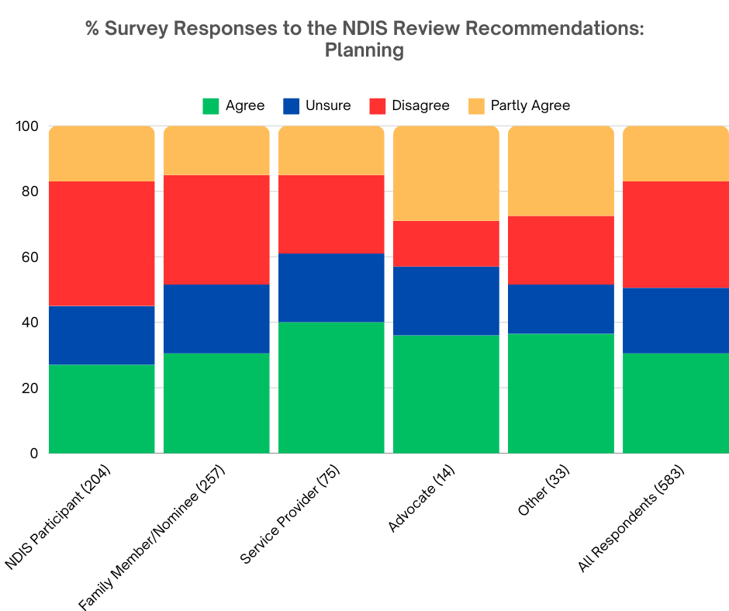

Based on EAC's analysis, a total of 280 comments were received regarding the question "What do you think of the suggested changes to planning?" Overall, there is a prevailing sense of apprehension surrounding the proposed alterations to planning. The key concerns raised by respondents include:
- Reintroduction of Independent Assessments: Many express concern that the proposed changes essentially equate to the reinstatement of independent assessments, arousing fears of reduced participant autonomy.
- Allied Health Professional Assessments: There are apprehensions regarding the proposal for support needs assessments to be conducted by allied health professionals employed or contracted by the NDIA. Questions arise about trust and potential conflicts of interest, along with concerns about the qualifications, skills, and impartiality of these professionals.
- Lack of Participant Choice and Control: Participants worry that the proposed changes may limit their ability to select the allied health professional responsible for conducting assessments, thus undermining their sense of choice and control.

Despite these concerns, respondents acknowledge potential benefits in the proposed changes, particularly in terms of enhanced flexibility. This includes the suggestion of setting budgets on a ‘whole of person’ level rather than individual support items, as well as the concept of flexible budgets replacing core and capacity-building supports.

However, there remains a prevailing feeling of unease regarding the perceived agenda behind the suggested changes, with many expressing overwhelming concern that they are a covert means to reintroduce independent assessments.

“Support needs assessment; This sounds a lot like independent assessments which I strongly disagree with.” ~ NDIS participant

“We fought against IAs [Independent Assessments], yet here they are again!” ~ NDIS participant

“Didn't we just fight off Independent Assessments, along with the Labor party? How are they getting away with foisting IAs [Independent Assessments] on us yet again, but without the independent bit?!?” ~ NDIS participant

“Just a sly way to bring in the Assessments they tried to bring in a few years ago.” ~ Family member or nominee for a NDIS participant

This fear is further evidenced and expressed through these respondent comments:

“I utterly reject Independent Assessments ver[sion] 2.0. What a kick in the guts, after the way our community fought against the previous version by the Morrison government. The thing that scares the hell out of me is that despite the messaging and subterfuge that everything will be okay, they are going to use these assessments to retest eligibility. I believe people with Psychosocial Disability are going to be targeted and removed from the NDIS. I don't trust them at all”. ~ NDIS participant

“Independent assessments are going to yield variable results depending on the skills and attitudes of the assessors and the participant’s ability to advocate. I have worked as an Early Childhood Coordinator for a number of years until recently. There is significant inequity in the current system and this approach will not improve outcomes for families or decrease stress levels unless it is very clear it is not adversarial.” ~ Interested person

A potential for loss of choice and Control had respondents concerned over the proposed changes to planning:

“How is this different from the previously proposed independent assessments? How will it be determined that the allied health assessor has the needed expertise in the supports that a participant needs? What are the minimum qualifications? There is already a shortage of OTs [Occupational Therapists] etc. Assessment must be informed by the participant’s treating professionals and allied health team. A multiple hour assessment by a non-expert stranger sounds like another form of gatekeeping. I think this will be a disaster. Participants will lose choice and control. This appears to be cost cutting by stealth.” ~ Family member or nominee for a NDIS participant

“No no no Need flexibility, choice and control. And independent people fron (sic) NDIA assessing and ‘navigating’.” ~ Family member or nominee for a NDIS participant

“This is just another way for NDIA and the govt to push independent assessments on everyone again. It erodes CHOICE AND CONTROL and is nothing more than a cost cutting tool to slash funding in participants plans.” ~ Family member or nominee for a NDIS participant

“Agree if choice of health professional is maintained and not reduced to monopoly of large companies removing choice and control.” ~ Employee of service provider

Numerous survey participants have raised concerns regarding the proposed support needs assessment being conducted by allied health professionals employed or contracted by the NDIA. Key themes frequently mentioned include doubts about the independence of these professionals, potential conflicts of interest, the challenge of professionals making decisions about individuals they are unfamiliar with, and apprehensions about excessive control being wielded by both the allied health professional and the NDIA.

“Support needs assessment should be completed by the person with disability's usual practitioner, not someone unknown. Causes unnecessary stress. What are the appeal mechanisms if unhappy with the assessment and/or budget[?]” ~ NDIS participant

“I am concerned about how well an unknown allied health professional would be able to assess and understand my uncommon disability.” ~ NDIS participant

“Reports should be done by allied health professionals that currently worth with the participant not an independent allied health professional supplied by NDIA this will need in disaster and participants will lose out in getting the right help them will become a burden to society I agree changes need to be made but not this way.” ~ Family member or nominee for a NDIS participant

“Always concerns when the NDIA is involved in assessment and recommendations rather that independent allied health professionals.” ~ Occupational Therapist

Continued workforce concerns persist regarding the competencies, qualifications, and expertise of the allied health professionals tasked with conducting the proposed needs assessments to determine participant funding budgets. As underscored in our analysis of other areas, a shortage of skilled allied health professionals and prolonged wait times for existing services will continue to compound these concerns.

“There is already a shortage of allied health practitioners in the NDIS arena. How will NDIS ensure the assessor has sufficient knowledge of a disability and its functional implications given the enormous range of disabilities. Where can the participant turn if they disagree with the assessment recommendations? How do the assessors ensure they see ‘the bad days’ not just the good days in disabilities that fluctuate?” ~ Family member or nominee for a NDIS participant

“Your waitlists and times to get plans turned around are already outrageous, how are you going to manage this?” ~ Family member or nominee for a NDIS participant

Respondents’ expressed apprehension that a Support Needs Assessment conducted by an allied health professional employed or contracted by the NDIA may lack the required knowledge or comprehensive understanding to make informed assessments about participants. Drawing from community feedback during the advocacy against Independent Assessments, there's a consensus that individuals with disabilities should exclusively be assessed by clinicians possessing in-depth expertise in their specific disability type and operating within a trauma-responsive framework. Trust and safety are paramount considerations in such assessments, and individuals with disabilities advocate for the right to choose the assessor who conducts any evaluations pertaining to them.

“I agree with a caveat - these professionals should be required to have input for all treating team members of the participant. You cannot possibly expect one person to assess someone’s needs that they have no working relationship with. If you understood the process of forming relationships with your client to build trust to be able to achieve goals this is be(sic) a requirement and not just a suggestion.” ~ Family member or nominee for a NDIS participant

“A few hours with a new therapist cannot understand a complex participant when some of our therapist takes months.” ~ Family member or nominee for a NDIS participant

“Allied health professions [who] do not know participants cannot make an assessment and base their judgement on a meeting with a participant. Long term knowledge is extremely important therefore this assessment should be done by all allied health professionals not only appointed ones.” ~ Family member or nominee for a NDIS participant

“How is someone who only spends a few hours with the participant an expert???” ~ Family member or nominee for a NDIS participant

The respondents expressed continuing uncertainty regarding whether the assessments would be one-off or ongoing, with many also expressing fatigue at the prospect of having to repeatedly explain their circumstances.

“Why do we have to be assessed every year for a disability that is not going to change? It’s degrading and create a[n] uncertainty and worry every year.” ~ NDIS participant

“The review calls for 6 monthly assessments which is stressful and traumatic for people.” ~ Employee of service provider

“I do not need to be assessed again. I am sick of being assessed! My disability is not going to disappear, I have had it my whole life. It is not genetic and it was just ‘luck of the draw’. I need certainty of funding. I am sick to death of explaining why I need AT [Assistive Technology]. The OT [Occupational Therapist] reports are insanely long for replacement of like for like.” ~ NDIS participant

The NDIS Review recommended that Support Needs Assessments may span multiple hours, prompting concerns among respondents about the potential stress it may induce.

“As a person with MS [Multiple Sclerosis] ‘multiple hours’ for an assessment would be hard with fatigue and pain. Concerns person wouldn’t understand my disability. Concerns not enough to gauge info in one session.” ~ NDIS participant

Numerous respondents felt that the planning changes proposed would increase complexities in accessing support, rather than simplifying and streamlining the system.

“Whatever the process changes to, it needs to not be so long and drawn out.” ~ NDIS participant

“This is an institutionalised approach.” ~ Family member or nominee for a NDIS participant

“This is ok for new participants but just a nightmare for us to go through everything again.” ~ Family member or nominee for a NDIS participant

There was a suggested way to improve the process for participants expressed as:

“Keep the paperwork and bureaucracy to a minimum.” ~ NDIS participant

Reducing bureaucracy was a suggestion echoed by many survey respondents:

“Concerned that this is overcomplicating the planning process. Why do so many people need to be involved? Should be one contact working with PWD [people with disability] and should be led by PWD [people with disability].” ~ NDIS participant

“I have too little info at present but it sounds very cumbersome, very expensive and not enough said about using the past to help shape/dictate the future.” ~ NDIS participant

The requirement for co-design of any of the implementation planned for support needs assessments was equally emphasised by many respondents:

“Supports needs assessment need to be co-designed. Once designed, they need to be delivered by a qualified allied health professional under AHPRA, working within their scope of practice. This can't become another IA [Independent Assessments].” ~ Family member or nominee for a NDIS participant

“Agree in principle but will need careful codesign and resourcing and accountability from government.” ~ Organisation employee

The proposal suggests implementing flexible budgets to replace Core and Capacity Building components. Additionally, plan budgets would be set at a "whole of person" level rather than focusing on individual support items. These two recommendations have garnered widespread support overall.

“A flexible budget that could be used across both core and capacity would be good. Being able to review the proposed plan before it is set in stone would be good. Any reports that are used to help build this should be completed by the participants existing health professionals - ie my own OT and physio, rather than someone who does not know me. Assessments completed by people with no experience with the participant do not form an accurate picture of needs.” ~ NDIS participant

“Plan budgets should be fully flexible.” ~ NDIS participant

“Some aspects of a person's disability change over time, so I do not agree that a housing and living budget should be fixed nor assistive technology supports. I think a person should be able to apply for extra funding based on their needs and their ability to function in certain areas of their life. For example, someone who has a permanent disability of a visual impairment may suffer from ongoing declines in their visual capacity or ability to function, which then affects their housing and living situation and they may require more visual aids to support them over time or supported technology.” ~

“The flexible budget across all supports will allow for supports to adapt especially where there is a condition that fluctuates in needs.” ~ Family member or nominee for a NDIS participant

Respondents also expressed concerns in relation to the issues of assistive technology and housing being ‘Stated Supports’, rather than flexible.

“Assistive technology and future supports should be flexible what’s good today may not be what’s needed tomorrow assistive technology should be flexible having so many different kinds of support is just confusing to the average person where if all supports were in one place and reasonably flexible reasonable or necessary what’s reasonable for one person may not be reasonable for another. The NDIS cannot be allowed to become a one size fits all because it will fail.” ~ NDIS participant

“Housing and living budget and stated supports for assistive technology and capital that would not be flexible with create major barriers in my opinion. Needs change and for someone with degenerative disorders who need different supports/Aids quickly this will not work!” ~ Family member or nominee for a NDIS participant

“Housing and living budget and stated supports for assistive technology and capital would ALSO NEED to be Flexible.” ~ Retired Occupational Therapist

“I strongly agree with all changes apart from the lack of flexibility for housing and living, and capital budgets. Participants needs can change during their plan. The NDIS' extremely poor response times for AT and other change of circumstances place participants at risk of injury when the plan cannot be used flexibly.” ~ Employee of service provider

Recommendation 7: Psychosocial Disability

The NDIS Review Report recommends these changes to how people with psychosocial disability would be supported:
- Government investment in mental health systems outside of the NDIS.
- Support from a trauma-informed Navigator with expertise in psychosocial supports.
- Early intervention pathway for most new participants with psychosocial disability (section 25 of the NDIS Act).
- Focus on personal recovery and increasing independence.
- Integrated complex care coordination approach between NDIS and public mental health systems for participants with complex needs.
- Requirement that psychosocial support providers be registered, provide evidence-based supports, and comply with a new support-specific practice standard (e.g. specific training in psychosocial disability).

See recommendation 7.1 to 7.6 of the report.

37% of survey respondents were in favour of the recommended changes to psychosocial disability supports in the NDIS Review report. 27% were unsure, while 23% disagreed or strongly disagreed. A further 13% of respondents agreed with some of the changes but not others.

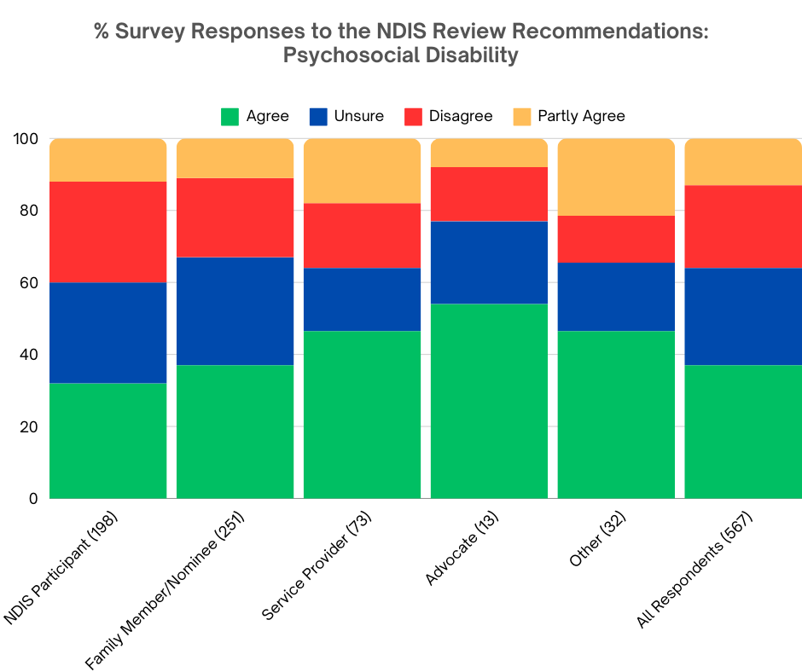

A total of 209 comments were received in response to the question, 'What do you think of the suggested changes to psychosocial disability supports?' Positive opinions were commonly expressed, including:
- Endorsement of psychosocial disability support options existing outside of the NDIS by 19 participants.
- In principle support for the suggested changes to psychosocial disability supports by 13 respondents.
- Recognition that the NDIS is broken and unsustainable, with urgent changes needed, as stated by 12 respondents.

However, negative opinions were prevalent, with concerns raised about:
- A lack of resources to implement the suggested changes to psychosocial disability supports, noted by 35 respondents.
- The possibility of the suggested changes leading to support gaps, as expressed by 24 respondents.
- Apprehension that mandatory registration of service providers will diminish choice and control, cited by 23 respondents.

Some respondents highlighted the unsustainable nature of the NDIS while strongly advocating for psychosocial disability supports outside of the Scheme. Conversely, others criticised the recommended changes as insufficient excuses to remove people from the NDIS forcibly. Additionally, concerns were frequently voiced about the potential risks to mental wellbeing, with fears that individuals with psychosocial disabilities could fall through service gaps created by the suggested changes. Furthermore, there were criticisms about a lack of consultation and co-design with the stakeholder group most affected by the proposed policy changes: people with lived experience of psychosocial disability.

Positive commentary for the recommended changes to psychosocial disability supports.

There were endorsements and support of the need for the proposed psychosocial disability support options outside of the NDIS:

“Psychosocial disability should sit outside of NDIS.” ~ Family member or nominee for a NDIS participant

“Should be under State dept of health.” ~ Family member or nominee for a NDIS participant

“Agree with Government investment outside the NDIS.” ~ Family member or nominee for a NDIS participant

“Need options outside the NDIS for support.” ~ Interested person

In relation to the proposed changes to supports for psychosocial disability there was a general agreement:

“The theory sounds great.” ~ Family member or nominee for a NDIS participant

“Sounds good on paper.” ~ Employee of a service provider

“Very positive step.” ~ Family member or nominee for a NDIS participant

“In theory, these are good ideas.” ~ Person with disability currently applying for NDIS (also an advocate)

Worryingly, there were many comments suggesting that the NDIS needs dramatic change:

“Needs a real shake up.” ~ Family member or nominee for a NDIS participant

“So many people claim mental health condition now, so it really needs to be investigated by proper authorities.” ~ NDIS Participant

In this area there were four respondents who provided their agreement that for psychosocial providers there was a requirement for them to be registered providers:

“Psychosocial supports being registered is a big yes.” ~ Family member or nominee for a NDIS participant

“I agree with the need for registration.” ~ Employee of a service provider

Negative opinions about the recommended changes to psychosocial disability supports

There were many comments provided concerning the continuing lack of resourcing in this area, and that changes would need to ensure that this is acknowledged, recognised and resolved before participants would receive any benefit:

“Proposals like this need to be supported by significant funding from the government for community supports.” ~ NDIS participant

“Public mental health services are not set up for the volume of people who would need to access it.” ~ Employee of a service provider

“The public system is already overworked.” ~ Family member or nominee for a NDIS participant

“The reality is our current health care system is already inadequate... Long wait times, and even long wait times at appointments.” ~ Family member or nominee for a NDIS participant

EAC reviewed the comments and further concerns emerged that the proposed changes would see support gaps increase or lead to gaps as a direct result:

“But again, pushing the responsibility to health just feel people will be left in the middle with no services.” ~ Family member or nominee for a NDIS participant

“People with psychiatric disabilities will be placed at risk.” ~ NDIS participant

“State equitable services will not be guaranteed and will impact on individuals ability to move interstate.” ~ Employee of a service provider

“It sounds way too controlling and buck passing and like just another way to say "not our responsibility.” ~ Family member or nominee for a NDIS participant

This area continued the concerns expressed in other sections; that any form of mandatory provider registration would result in a diminishing or removal of participants’ choice and control, seen as a fundamental tenet of the Scheme:

“Psychosocial participants need to be able to choose who supports them more than anyone does.” ~ NDIS participant

“Again sounds like taking choices away and forcing people to do what they're told is best for them.” ~ Family member or nominee for a NDIS participant
“I don't think psychosocial support providers need to be registered as that will remove choice and control.” ~ Family member or nominee for a NDIS participant

“Looks another drive of one size fits all.” ~ Family member or nominee for a NDIS participant

Concerns strongly emerged that these changes may be designed to ensure participants of psychosocial disability supports are forced out of the scheme:

“From the above it seems the NDIS is trying to wipe their hands clean of helping those with psychosocial disabilities.” ~ NDIS participant

“Again feels like cracking down on disabled people instead of fixing the real issues of price gouging etc.” ~ NDIS participant

“Is this another attempt to exclude autistic people.” ~ Family member or nominee for a NDIS participant

“It feels more like the NDIS is kicking out people with psychosocial disability.” ~ Parent currently applying for NDIS access for a family member

Comments raised that changes were not required, that they would be unachievable if not a waste or misuse of resources that wouldn’t deliver positive outcomes for participants:

“I am sceptical that this approach is a achievable and think we will end up with a system of supports that do not meet participants needs.” ~ Family member or nominee for a NDIS participant

“Pity you didn't have a hysterical laughter option because that's the one I would have ticked.”
Clinician who regularly deals with people on or applying for NDIS access

For some respondents, the short timeframes proposed for early intervention for people with psychosocial disability failed to reflect that a psychosocial disability is lifelong and requires that level of support, along with issues concerning how complexity would be defined.

“NDIS was always meant to be lifelong, not up to 3 years.” ~ NDIS participant

“Many things, like autism & ADHD, are not things you can 'recover' from.” ~ Family member or nominee for a NDIS participant

“Who decides complex needs?” ~ NDIS participant

“I have difficulty understanding why psychosocial supports are not included.” ~ NDIS participant

Many respondents also reported concerns about a lack of detail and evidence to support the suggested changes:

“Unable to support these proposed changes as there is no concrete ideas of how these would work.” ~ Employee of a service provider

“Not enough details to make an opinion and no trust left in the government.” ~ Employee of a service provider

Dissatisfaction with the consultation undertaken in designing the proposed changes came through from several respondents, and the lack of any codesign was specifically mentioned along with significant concerns for support reduction or loss in rural and rural remote areas:

“Hello? I'm supposed to have the cognitive impairment here. Not the policy wonks writing this stuff.” ~ NDIS participant

“The consultation was largely closed.” ~ Family member or nominee for a NDIS participant

Several respondents mentioned their concerns that the suggested changes to psychosocial disability supports are inequitable and discriminatory:

“This is discrimination and against our human rights.” ~ NDIS participant

“The stated separation of how psychosocial disabilities are going to be handled feels discriminatory.” ~ NDIS participant

“Once again, it sounds like this has been decided by people in large cities…in regional and rural areas it is often difficult to find practitioners experienced in psychosocial disabilities.” ~ Family member or nominee for a NDIS participant

“Resourcing this sector is a huge concern especially in regional and rural areas.” ~ Employee of a service provider

Recommendation 1: Foundational Supports

The NDIS Review Report recommends that Governments fund Foundational Supports for people with disability outside of the NDIS. There would be two types of Foundational Supports.

General supports:
- For all people with disability under the age of 65.
- Includes navigation support, peer support, self-advocacy, disability employment supports, information and capacity building for individuals, families and communities.

Targeted supports:
- For people 0-65yrs not eligible for NDIS and in most need of additional support.
- Includes home and community care, aids and equipment, early childhood supports, psychosocial supports and transition supports for youth.

Recommendations for Foundational Supports outside the NDIS would include:
- Invest in and redesign information, advice and capacity building supports (Information, Linkages and Capacity building).
- Navigation support for people with disability outside the NDIS (helping people with disability to access mainstream services).
- Early support for kids with development concerns and disability.
- Capacity building for families and carers of kids with developmental concerns and disability.
- Home and community care programs for people with disability outside the NDIS.
- Nationally consistent aids and equipment program outside the NDIS.
- More mental health supports outside NDIS.
- Support for youth aged 9 to 21 years to manage key transition points (e.g. secondary school, employment and living independently).

See recommendation 1, page 4 of the report.

The disability community responding to the survey gave in principle support to the recommendation for foundational supports, but raised concerns about how such supports would be implemented. Overall, 47% of respondents agreed or strongly agreed with the recommendation for Foundational Supports, while 26% responded that they were unsure about this recommendation. Only 18% disagreed or strongly disagreed with the proposal for foundational supports to be introduced outside the NDIS.

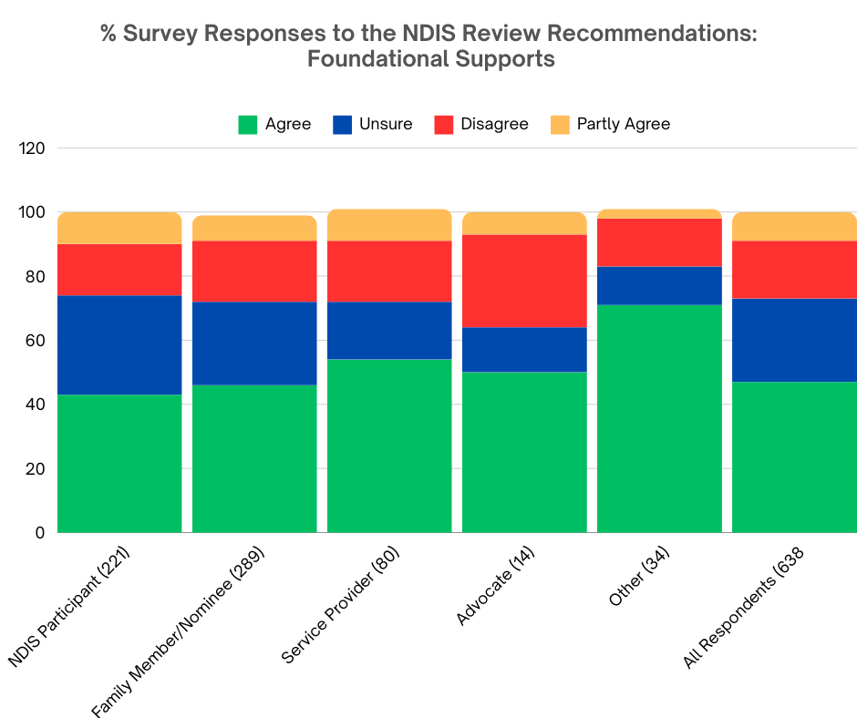

“Navigation support is most probably necessary particularly for those who do not have more intensive needs and certainly is better than having nothing available even if they are little more than a referral service in practice.” ~ NDIS participant

“It also needs to be backed by real options for actual ‘boots on the ground’ help, and not just more of the ‘glossy brochure syndrome’: promising glowing outcomes on paper, but leading to zero actual support.” ~ NDIS participant

When asked about the two types of foundational supports proposed, General and Targeted, 41% of survey respondents were supportive of the two types, while 29% were unsure about this recommendation. A further 21% disagreed or strongly disagreed with the recommendation for General and Targeted supports, and 10% agreed with some of the changes but not others.

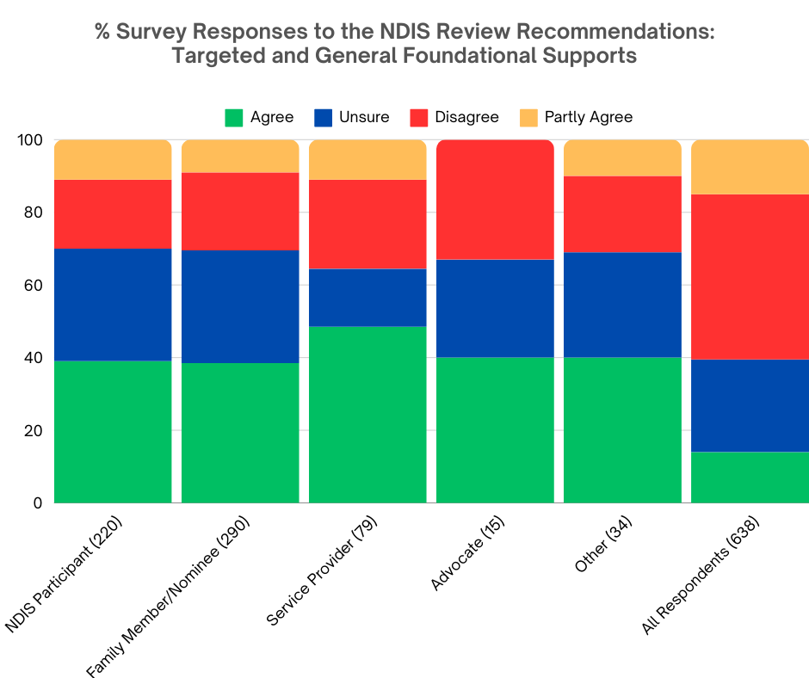

Sixty-one respondents conveyed positive opinions, expressing that the recommendation presented opportunities for foundational supports to address gaps in NDIS supports. Our analysis indicated that these respondents also expressed agreement with the two types of foundational supports in principle. Additionally, many respondents highlighted the potential for foundational supports to address existing gaps in NDIS supports.

“Supports should be available to whoever need them…we are in a wealthy country.” ~ NDIS participant

“I definitely agree with funding supports outside of the NDIS.” ~ NDIS participant

“I agree with foundational supports in principle.” ~ Employee of a service provider

“I want the arguing of who funds what to stop and people with disability be helped.” ~ NDIS participant

“I'm so glad that people with disability will be eligible for assistance outside the core NDIS” ~ NDIS participant

“I agree that there is a dire need for supports outside the NDIS.” ~ NDIS participant

“More support for people who don’t qualify for the Ndis would be terrific.” ~ Family member or nominee for a NDIS participant

“I agree that the government should fund things for disabled folks who aren’t necessarily eligible for NDIS.” ~ Person with disability outside the NDIS

There was a positive take on this recommendation by some respondents who believed that there would be opportunities to assist people with disability and families in navigating mainstream and disability services and supports through the proposed navigators.

“Navigation support is most probably necessary particularly for those who do not have more intensive needs and certainly is better than having nothing available even if they are little more than a referral service in practice.” ~ NDIS participant

“[People] with a disabled child need to be enveloped in significant support, mentoring and practical assistance whilst they navigate diagnosis and engagement with therapists etc.” ~ Family member or nominee for a NDIS participant

A considerable portion of survey respondents voiced apprehensions regarding the potential for inadequate funding, resourcing, and accountability mechanisms associated with foundational supports. Within the community, there exists a prevalent narrative of individuals experiencing negative or inconsistent interactions with the current NDIS Partner In The Community (PITC) arrangements. Concerns were repeatedly raised that similar challenges would occur within the proposed framework of foundational supports, or that foundational supports may fail to fulfil their intended objectives. This apprehension underscores the importance of robust oversight and transparent mechanisms to ensure that foundational supports effectively address the needs of participants, without replicating the failures experienced in existing arrangements.

“It [foundational supports] also needs to be backed by real options for actual ‘boots on the ground’ help, and not just more of the ‘glossy brochure syndrome’: promising glowing outcomes on paper, but leading to zero actual support.” ~ NDIS participant

“Supports need to be properly funded to ensure there are no unmet needs and no need to try and gain access to the NDIS.” ~ Family member or nominee for a NDIS participant

“It ignores the complexity of needs that people with disability may have. Slipping through the cracks of a system like this could be fatal.” ~ Family member or nominee for a NDIS participant

“I am extremely concerned that the NDIS will refer people to these foundational supports before they are actually available.” ~ Family member or nominee for a NDIS participant

Respondents frequently expressed concerns about the proposed foundational supports and changes to the NDIS, deeming them unnecessary and potentially harmful. They questioned the need for additional layers within the NDIS framework, and feared that these changes could increase existing complexities, leading to confusion and inefficiency, and gaps in support. Respondents stressed the importance of careful consideration and evidence-based decision-making to reduce risks and ensure positive outcomes for participants.

“I am concerned that the 'foundational supports' like other systems will have gaps and Australians that fall within these gaps who may lose essential services thus reducing their quality of life due to increased disability experienced from not being able to obtain the required support.” ~ NDIS participant

“You're either eligible or you're not…sounds like some kind of lateral ableist bullshit to me.” ~ NDIS participant

“Stop overhauling things and wasting good funding - that is what people with disability want.” ~ Family member or nominee for a NDIS participant

“Just a new way to deny people support that they need.” ~ Family member or nominee for a NDIS participant

Respondents expressed concerns about the proposed foundational supports and NDIS changes, citing doubts about their necessity and potential negative impacts. Many questioned the need for additional layers within the NDIS, fearing they could further complicate an already complex system without clear benefits. Additionally, there were worries that these changes might increase existing challenges and divert resources away from addressing them. Respondents stressed the importance of thorough codesign with people with disability and evidence-based decision-making to ensure positive outcomes for individuals with disabilities.

Numerous respondents also voiced concerns and confusion regarding the insufficient detail provided about the delivery and resourcing of the two types of foundational supports. Additionally, there were apprehensions that these supports may not adequately address the needs of people with disabilities. Many viewed the policy approach as primarily driven by cost-saving motives, potentially leaving people with disabilities without the personalised supports required to meet their needs:

“I feel like this goes back to the pattern which existed before NDIS, but worry about those not in large metropolitan areas and their ability to access supports.” ~ Family member or nominee for a NDIS participant

“It’s not easy for a neurodivergent let alone when they live in the country…nothing is close by and learning to drive is going to be a barrier and if able will need to be done with the right person.” ~ Family member or nominee for a NDIS participant

“It ignores the complexity of needs that people with disability may have. Slipping through the cracks of a system like this could be fatal.” ~ Family member or nominee for a NDIS participant

“There is not enough clarity about how foundational supports will be funded, accessed or serviced.” ~ NDIS participant

“The concept it is not clear.” ~ Employee of a service provider

“If the NDIS really wants to save money stop forcing people to use greedy providers.” ~ NDIS participant

“I do not understand the reasoning behind this and am concerned that it is an attempt to limit who should receive NDIS support.” ~ NDIS participant

A recurring concern highlighted in survey responses centred on apprehensions regarding the adequacy of the two types of foundational supports (Targeted and General) in meeting the diverse and individualised needs of people with disabilities. Respondents expressed unease that these supports may not sufficiently address the unique requirements and circumstances of individuals, potentially resulting in gaps or inadequacies in the support provided. This concern stemmed from a perception that the proposed foundational supports would likely adopt a broad, one-size-fits-all approach, overlooking the diverse and unique needs of people with disabilities.
Consequently, there were reservations about the ability of these supports to effectively cater to the specific requirements and preferences of individuals, potentially falling short in facilitating their full participation and inclusion in society.

“Takes away flexibility to work out supports that suit individual needs.” ~ NDIS participant

“These supports are a good idea, however people are individual and everyone needs support for different things.” ~ Family member or nominee for a NDIS participant

“This approach is once again a one size fits all approach that doesn’t address the specific support and access needs of disabled INDIVIDUALS.” ~ Family member or nominee for a NDIS participant

“The other issue is this is basically a return to limited block funding rather than individualised support and completely undermines another key principle of the NDIS.” ~ Clinician

Additionally, respondents expressed concerns about the discriminatory impact of the proposed foundational supports, particularly in relation to people with disability aged 65 years and older. They feared that these supports would exclude this demographic group, depriving them of essential services. Similarly, there were worries that the targeted supports might not adequately assist individuals with psychosocial disabilities and could perpetuate discrimination against them. These concerns highlighted the need for inclusive and equitable support provisions that cater to individuals of all ages and disability types, ensuring dignity and autonomy for all.

“Price gouging and difference in supports if you are over 65 is wrong.” ~ Family member or nominee for a NDIS participant
“Should be open to all ages not limited to under 65 years of age.” ~ Employee of a service provider

“Shoving disabled seniors into nursing homes will result in an increase in neglect.” ~ Advocate

“Don’t single out psychosocial disability…it’s discrimination.” ~ NDIS participant

“Psychosocial supports need to be included in General Supports…to specifically not include this is discriminatory.” ~ Employee of a service provider

Numerous respondents expressed optimism regarding the potential of foundational supports to provide access to support for individuals with disabilities who do not qualify for the NDIS. They viewed these supports as a promising avenue for extending assistance to people with disability outside the NDIS, thereby addressing gaps in the existing support framework. This optimism reflected a broader recognition within the disability community of the importance of ensuring equitable access to support services for all individuals, regardless of their eligibility for specific schemes or programmes.

“Supports should be available to whoever need them…we are in a wealthy country.” ~ NDIS participant

“I want the arguing of who funds what to stop and people with disability be helped.” ~ NDIS participant

In line with the principle of ‘nothing about us without us’ which underpins disability inclusion efforts, many NDIS participants advocated for the co-design of foundational supports in collaboration with individuals with disabilities and their representative organisations. They emphasised the importance of involving people with disabilities in the design process to ensure that the supports meet their needs and preferences effectively. Additionally, these participants expressed a lack of trust in the Government and the NDIA, underscoring the need for transparent and inclusive decision-making processes that prioritise the voices and experiences of people with disabilities.

“It would depend on the ability to listen to the disability community about what they needed…this hasn't been displayed very well up to this point so I have low confidence.” ~ NDIS participant

Contact Details

Every Australian Counts

Dr George Taleporos
Independent Chair

Email: drtaleporos@gmail.com
Email: communications@everyaustraliancounts.com.au
Website: www.everyaustraliancounts.com.au

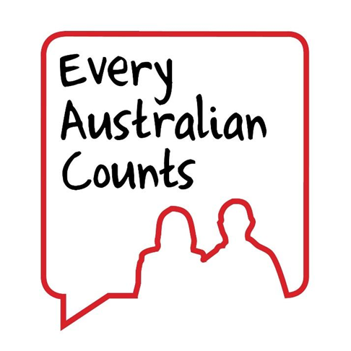

“Nothing about us without us.”

Appendix 1: Tables of Survey Results By Respondent Type

Q.2 What do you think of the recommended changes to housing and living supports?
 | All respondents | Advocate | Employee of service provider | Family member or nominee for a NDIS participant | NDIS participant | Other
Number of responses | 725 | 15 | 90 | 338 | 241 | 41
Statement | Percent | Percent | Percent | Percent | Percent | Percent
Agree and strongly agree | 14 percent | 33 percent | 24 percent | 11 percent | 11 percent | 27 percent
Unsure | 25 percent | 20 percent | 18 percent | 25 percent | 30 percent | 24 percent
Disagree and strongly disagree | 45 percent | 27 percent | 41 percent | 48 percent | 47 percent | 32 percent
I agree with some of the changes but not others | 15 percent | 20 percent | 17 percent | 16 percent | 12percent | 17 percent
Total | 100 percent | 100 percent | 100 percent | 100 percent | 100 percent | 100 percent

Q.3 What do you think of the recommendation for mandatory provider registration?
 | All respondents | Advocate | Employee of service provider | Family member or nominee for a NDIS participant | NDIS participant | Other
Number of responses | 684 | 15 | 89 | 311 | 233 | 36
Statement | Percent | Percent | Percent | Percent | Percent | Percent
Agree and strongly agree | 23 percent | 40 percent | 44 percent | 22 percent | 13 percent | 33 percent
Unsure | 9 percent | 13 percent | 8 percent | 10 percent | 8 percent | 6 percent
Disagree and strongly disagree | 57 percent | 40 percent | 36 percent | 58 percent | 68 percent | 31 percent
I agree with some of the changes but not others | 12 percent | 7 percent | 12 percent | 10 percent | 12 percent | 31 percent
Total | 100 percent | 100 percent | 100 percent | 100 percent | 100 percent | 100 percent

Q.4 What do you think of the two types of Foundational Supports?
 | All respondents | Advocate | Employee of service provider | Family member or nominee for a NDIS participant | NDIS participant | Other
Number of responses | 638 | 15 | 79 | 290 | 220 | 34
Statement | Percent | Percent | Percent | Percent | Percent | Percent
Agree and strongly agree | 40 percent | 40 percent | 48 percent | 38 percent | 39 percent | 53 percent
Unsure | 29 percent | 27 percent | 16 percent | 31 percent | 31 percent | 18 percent
Disagree and strongly disagree | 21 percent | 33 percent | 24 percent | 21 percent | 19 percent | 18 percent
I agree with some of the changes but not others | 10 percent | 0 percent | 11 percent | 9 percent | 11 percent | 12 percent
Total | 100 percent | 100 percent | 100 percent | 100 percent | 100 percent | 100 percent

Q.5 What do you think of the recommendation for Foundational Supports?
 | All respondents | Advocate | Employee of service provider | Family member or nominee for a NDIS participant | NDIS participant | Other
Number of responses | 638 | 14 | 80 | 289 | 221 | 34
Statement | Percent | Percent | Percent | Percent | Percent | Percent
Agree and strongly agree | 47 percent | 50 percent | 54 percent | 46 percent | 43 percent | 71 percent
Unsure | 26 percent | 14 percent | 18 percent | 26 percent | 31 percent | 12 percent
Disagree and strongly disagree | 18 percent | 29 percent | 19 percent | 19 percent | 16 percent | 15 percent
I agree with some of the changes but not others | 9 percent | 7 percent | 10 percent | 8 percent | 10 percent | 3 percent
Total | 100 percent | 100 percent | 100 percent | 100 percent | 100 percent | 100 percent

Q.6 What do you think of Navigators?
 | All respondents | Advocate | Employee of service provider | Family member or nominee for a NDIS participant | NDIS participant | Other
Number of responses | 620 | 15 | 78 | 279 | 214 | 34
Statement | Percent | Percent | Percent | Percent | Percent | Percent
Agree and strongly agree | 23 percent | 33 percent | 27 percent | 24 percent | 18 percent | 35 percent
Unsure | 20 percent | 27 percent | 13 percent | 22 percent | 21 percent | 15 percent
Disagree and strongly disagree | 42 percent | 27 percent | 45 percent | 40 percent | 46 percent | 35 percent
I agree with some of the changes but not others | 15 percent | 13 percent | 15 percent | 14 percent | 15 percent | 15 percent
Total | 100 percent | 100 percent | 100 percent | 100 percent | 100 percent | 100 percent

Q.7 What do you think of the suggested changes to eligibility and access?
 | All respondents | Advocate | Employee of service provider | Family member or nominee for a NDIS participant | NDIS participant | Other
Number of responses | 607 | 15 | 77 | 271 | 210 | 34
Statement | Percent | Percent | Percent | Percent | Percent | Percent
Agree and strongly agree | 48 percent | 40 percent | 68 percent | 46 percent | 44 percent | 53 percent
Unsure | 20 percent | 27 percent | 12 percent | 26 percent | 17 percent | 6 percent
Disagree and strongly disagree | 20 percent | 20 percent | 10 percent | 18 percent | 25 percent | 18 percent
I agree with some of the changes but not others | 12 percent | 13 percent | 10 percent | 10 percent | 14 percent | 24 percent
Total | 100 percent | 100 percent | 100 percent | 100 percent | 100 percent | 100 percent

Q.8 What do you think of the recommended changes to early intervention?
 | All respondents | Advocate | Employee of service provider | Family member or nominee for a NDIS participant | NDIS participant | Other
Number of responses | 592 | 14 | 76 | 264 | 205 | 33
Statement | Percent | Percent | Percent | Percent | Percent | Percent
Agree and strongly agree | 39 percent | 36 percent | 45 percent | 43 percent | 32 percent | 42 percent
Unsure | 31 percent | 29 percent | 22 percent | 30 percent | 39 percent | 15 percent
Disagree and strongly disagree | 17 percent | 0 percent | 16 percent | 17 percent | 18 percent | 18 percent
I agree with some of the changes but not others | 12 percent | 36 percent | 17 percent | 9 percent | 11 percent | 24 percent
Total | 100 percent | 100 percent | 100 percent | 100 percent | 100 percent | 100 percent

Q.9 What do you think of the suggested changes to planning?
 | All respondents | Advocate | Employee of service provider | Family member or nominee for a NDIS participant | NDIS participant | Other
Number of responses | 583 | 14 | 75 | 257 | 204 | 33
Statement | Percent | Percent | Percent | Percent | Percent | Percent
Agree and strongly agree | 31 percent | 36 percent | 40 percent | 30 percent | 27 percent | 36 percent
Unsure | 20 percent | 21 percent | 21 percent | 21 percent | 18 percent | 15 percent
Disagree and strongly disagree | 33 percent | 14 percent | 24 percent | 33 percent | 38 percent | 21 percent
I agree with some of the changes but not others | 17 percent | 29 percent | 15 percent | 15 percent | 17 percent | 27 percent
Total | 100 percent | 100 percent | 100 percent | 100 percent | 100 percent | 100 percent

Q.10 What do you think of the suggested changes to psychosocial disability supports?
 | All respondents | Advocate | Employee of service provider | Family member or nominee for a NDIS participant | NDIS participant | Other
Number of responses | 567 | 13 | 73 | 251 | 198 | 32
Statement | Percent | Percent | Percent | Percent | Percent | Percent
Agree and strongly agree | 37 percent | 54 percent | 47 percent | 37 percent | 32 percent | 47 percent
Unsure | 27 percent | 23 percent | 18 percent | 30 percent | 28 percent | 19 percent
Disagree and strongly disagree | 23 percent | 15 percent | 18 percent | 22 percent | 28 percent | 13 percent
I agree with some of the changes but not others | 13 percent | 8 percent | 18 percent | 11 percent | 12 percent | 22 percent
Total | 100 percent | 100 percent | 100 percent | 100 percent | 100 percent | 100 percent

