Day of Action

Hosted by Speak Out

Thursday

28th of April

11:00 AM

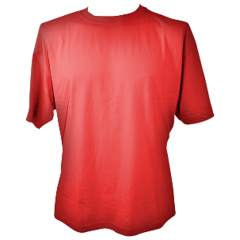

Dress in red to show your support

Meeting at   
Burnie Beach

