Immediate Proactive Response to Coronavirus (COVID-19) for Australians with Disability

The following is a list of issues that need to be addressed urgently to ensure the wellbeing of people with disability during the current COVID-19 public health emergency.

Endorsed by:
- Australian Federation of Disability Organisations
- Children and Young People with Disability
- Disability Advocacy Network Australia
- Every Australian Counts
- First People Disability Network
- Inclusion Australia
- National Ethnic Disability Alliance
- People with Disability Australia
- Women with Disabilities Australia
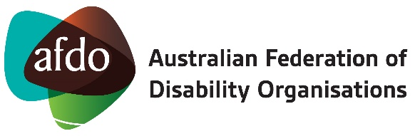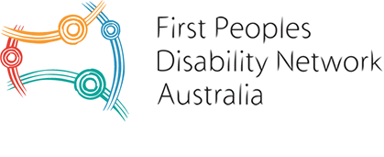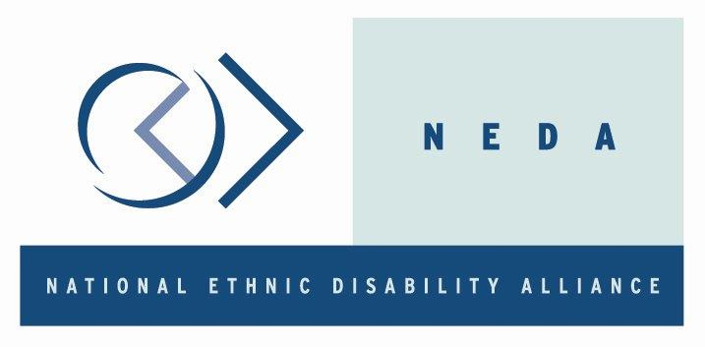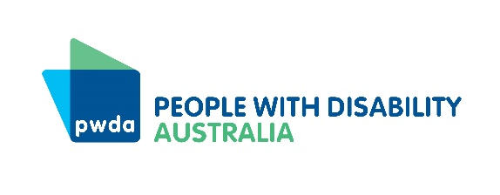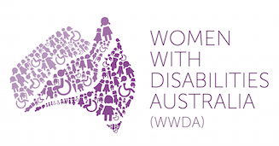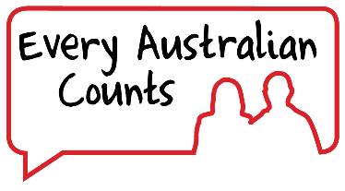

Cross-organisational issues:

Establish a Disability Task-force immediately to bring together representatives from disabled people's organisations, disability advocacy and representative organisations, the disability service system, representatives from health and education and other relevant stakeholders.

Immediate welfare of people with disability
- Ensure continuity of supports, both via the NDIS and other supports. [See more detail below.]
- Resource existing national information services to expand and be available to manage requests related to COVID-19 from people with disability, particularly those who may not have access to the internet.
- Resource and establish a proactive, phone-based outreach program to existing NDAP providers to enable advocates to connect and check in with people with disability. This program would also actively engage with any other person with disability in the region that the NDAP provider operates. The phone based outreach program would undertake the following tasks:

  - Simply asking how the person with disability is going?
  - Do they require any equipment or supplies? If so investigate ways that these may be purchased online
  - Schedule a follow up phone call.

- Establish a national prioritised delivery service for essential goods for people with disability such as sanitising equipment, continence aids and medical consumables (eg medical swabs, PEG feeding support, catheters, wound dressings).
- Active and ongoing liaison with states and territories to ensure full inclusion of people with disability in all plans to deal with COVID-19.
- Equal access to essential goods, such as groceries and food.
- All information to be provided in plain English, Easy Read and Auslan, and departments will liaise with disability peak organisations about vital communications before the information is sent out or posted to ensure it is disability friendly and accessible.

Supports and the NDIS
- Ensure people with disability, both who contract COVID-19 and those who don’t, are provided essential supports and services from providers (especially accommodation providers) at all times, by providing additional financial supports where needed. This can be administered through the NDIA.
- Establish an emergency COVID-19 NDIS response to ensure that people with disability can more flexibly utilise their plans to manage the current emergency, get information to people with disability, and to ensure continuity of supports.
- Continuity of supports for people with disability will include:
  - Provisions for replacement of support workers at no financial penalty
  - Plans to manage support provision if the person with disability contracts COVID-19
  - Plans to manage support provision if disability support workers contract COVID-19
  - Plans to manage support provision if the person with disability does not contract COVID-19
  - Plan flexibility to allow for changes, including more funding if needed, when circumstances change, such as when schools, day services and congregate settings close
  - No reduction of money for under-utilisation of plans
  - Phone based reviews
  - No extra delays to access, planning or review decisions

Other disability supports
- For the many people with disability not on the NDIS, create a mainstream state/territory response team, who are responsible for ensuring providers maintain capacity to continue the provision of services and support provision. Where appropriate, the response team can facilitate support and referral pathways, information and resources from other government agencies.
- Expansion of Home and Community Care services by states and territories.

Healthcare
- Fully cost and implement a disability specific package similar to that for older people which includes a suite of health-based initiatives such as:
  - accessible clinics and testing
  - telehealth resourcing
  - priority access to personal protective equipment such as masks and sanitiser
  - continuation of chronic care plans
  - expand access to home visits by GPs
  - expand access to telehealth

- All guidelines about triage or management of COVID-19 will ensure that people with disability will have equal access to health care, including ICU and other intensive treatment.

Employment and income support
Provide accessible facilities for the many people with disability who will need to work from home to ensure equal access to work from home provisions.
Ensure people with disability who need to self-isolate will not be discriminated against by their employers.
Ensure access to special leave for people with disability who don’t have COVID-19 but still need to self-isolate when they are not able to work from home and/or they don’t have other leave provisions available to them.
Suspend all in-person mutual obligation requirements on Newstart and other income support payments, such as the Disability Support Pension. People who are applying for income support payments because they are not able to work must also have those applications dealt with quickly.

Education
Allow people with disability who are studying to access their course work from home. They will need:
- Flexible arrangements for accessing course material and assessment
- No penalty for needed flexible arrangements
- Accessible access to course material and assessments
Ensure equal access to all school materials if students with disability are required to study from home.
Ensure there are plans to support University and TAFE students with disability if they are shut down.
Ensure there is clear communication with families about what is happening including what to do about keeping children and young people with disability safe.

Ensure there are clear plans for families of children with disability if schools and early childhood services are shut down including making reasonable adjustments for children and students with disability if their education is to continue at home

Telecommunications
- Establish a very low cost NBN package for people with disability who need access to the internet with Health Care Card (HCC) or Pension Concession Card (PCC)
- Establish a very low cost mobile phone package for people with disability with HCC or PCC

Disability Royal Commission
Extend time for the DRC to do its work, including allowing more time for the Interim report

Communities of people with disability issues:

Aboriginal and Torres Strait Islander people with disability

First Peoples with disability are especially vulnerable to COVID-19. Many First Peoples with disability live in poverty, or in overcrowded housing or in situations that mean that they have a higher number of risk factors for contracting COVID-19. First Peoples Disability Network (FPDN) is seeing an increasing volume in contacts from First people with disability and their families with concerns about the Coronavirus, but FPDN is not resourced adequately to be able to meet this demand.

Address the following three major priorities:

- First peoples with disability need access to a specific outreach program be it phone based or otherwise (dependent on health advice in terms of social isolation), administered by FPDN, across communities that FPDN knows have the least coverage in terms of access to existing NDAP providers.
- A major barrier for many First Peoples with disability and their families is access to information. Critically information must be provided in language and also be explained in an accessible way. To this end FPDN is currently developing a range of simple video messages that could be distributed widely.
- Finally FPDN remains seriously concerned about access to disability equipment and supplies particularly for regional and remote communities. It is critical that the current disability specific equipment and supply situation across regional and remote Australia be determined and acted upon immediately. This is a task that FPDN is ready to undertake immediately.

People with disability from culturally and linguistically diverse backgrounds
- Provide urgent access to translated materials about the COVID-19 public health emergency to people with disability from culturally and linguistically diverse backgrounds.
- Target information to address group events such as church and mosque attendance, and to engage with new and emerging community groups.

People with intellectual disability
- Make all information available in Easy Read formats for people with intellectual disability.

Women and girls with disability
- Provide access to sanitary products.
- Extend emergency domestic and family violence prevention packages to all states and territories.

Children and young people with disability

- Ensure flexibility in NDIS supports as younger children tend not to have any support worker time in their NDIS plans as children’s services close
- Establish a plan for of children and young people with disability that spans employment of families of children and young people with disability, NDIS, Health, Education, that takes an intersectional approach (CALD, First Nations, rural and remote issues etc)
- Establish a central coordinating taskforce specifically for children and young people with disability aged 0- 25, in partnership disability advocacy organisations, to oversee the response
- Establish strong communications targeted at this cohort and tailored to their needs, in consultation with disability advocates
- Boost funding for advocacy organisations that work with children and young people with disability, noting NDAP does not fund many organisations that provide specialist support for children and young people, these are mainly funded by states and territories and are currently overwhelmed with demand, even before the crisis.

People with psychosocial disability
- Extend access to mental health plans
- Provide counselling services - appropriate and targeted - to manage significant fears of people with disability.

Deaf Auslan users

- Take into account in the provision of any information the fact that this community use Auslan as their first language not English.

Deafblind Community
- Take into account that this community has significant issues with communication to ensure they all fully understand any issue. Information needs to be in a range of formats, Auslan, tactile interpreting, captioning, large print, braille, electronic, etc.

Hard of hearing and Deaf community
- Require messaging on all television media with open captions for this community. A variety of information in other formats as previously outlined will also be used by various members of this community.

